

WebNibbler LT
User Manual

WebNibbler LT ver. 1.01
Document Revision No. 1.03
Revision Date: November 28, 2005

Copyright Notice
Copyrightⓒ CCMedia, Inc., All rights Reserved.
CCMedia, Inc. owns the copyright of this guide. No part of this manual may be cited, reproduced or transmitted in any form or by any means, electronic or mechanical, without the consent of CCMedia, Inc.

trademarks
WebNibbler®, WebNibbler LT, eBrother, WEPA are trademarks of CCMedia, Inc.

Note
The information in this document is subject to change to include updates or to correct errata, without notice. All statements, information, and recommendation in this manual are believed to be accurate but are presented without warranty of any kind, express or implied. Users must take full responsibility for their application of any products.

CCMedia, Inc.
7F, Shinsegae I&C Bldg.
197-12 Guro-dong, Guro-gu, Seoul, Korea

TEL: +82-16-584-0506
FAX: +82-2-501-6340
http://www.ccmedia.com

Table of Contents

PREFACE vi
Who Should Read This Manual? vi
Summary of Contents vi
PART I. INTRODCUTION TO WEBNIBBLER LT 7
Summary of Contents 7
Chapter 1. Introduction to WebNibbler LT 8
Summary of Contents 8
A. Welcome 9
B. System Requirements 10
1. Operating Systems Supported 10
2. Web servers Supported 10
3. Hardware Requirements 10
C. WebNibbler LT at a Glance 11
1. Overview 11
2. Main Advantages 11
3. WebNibbler LT Modules 13
3.1. Overview 13
3.2. What is Gatherer? 14
3.3. What is UserMatcher-Client? 15
3.4. What is Recovery-Transfer? 16
3.5. What is Recovery-Receiver? 16
3.6. What is RPTPre? 16
3.7. Overall System Diagram 18
3.8. Workflow of WebNibbler LT 19
4. Preparing Installation 20
PART II. INSTALLING WEBNIBBLER LT SERVER 22
Chapter 1. Setup For MS Windows 2000 or 2003 23
A. Before You Begin 24
1. System Requirements 24
2. Main Modules of WebNibbler LT Server 24
3. Directories of WebNibbler LT Server 25
B. Installation 26
1. Begin Installation 26
2. System Requirements 26
3. License Agreement 27
4. Entering Serial Number 27
5. Selecting Destination Directory 28
6. Module Information Setup 29
7. Copying Files 30
8. Installation Completed 30
Chapter 2. Setup For Unix or Linux 1
A. Overview 2
1. System Requirements 2
2. Main Modules of WebNibbler LT Server 2
3. Directories of WebNibbler LT Server 3
B. Installation 4
1. Begin Installation 4
2. License Agreement 4
3. Entering Serial Number 4
4. Entering Destination Directory 5
5. Inputting Recovery Receiver Information 5
6. Confirming Installation Information 6
7. Copying Files and Setting up Environment 6
PART III. INSTALLING WEBNIBBLER LT CLIENT 7
Chapter 1. Setup For MS Windows 2000 or 2003 8
A. Before You Begin 9
1. System Requirements 9
2. Main Modules of WebNibbler LT Client 10
B. Installation 10
1. Begin Installation 10
2. System Requirements 11
3. License Agreement 11
4. Entering Serial Number 12
5. Selecting Modules To Install (Selecting Server Environment) 12
6. Installing Selected WebNibbler LT Client Modules 13
6.1. Installing Both Gatherer And UserMatcher-Client 14
6.1.1. Selecting Destination Directory 14
6.1.2. Basic Information Setup 14
6.1.3. Setting Up Web Server Environment 16
6.1.3.1. Apache Environment Setup 16
6.1.3.2. IIS Environment Setup ¨ 18
6.1.3.3. Netscape/iPlanet Environment Setup 19
6.1.4. Cookie Information Setup 20
6.1.5. Excluded Log Setup (Log Filtering) 23
6.1.6. UserMatcher-Client Setup 24
6.1.7. Confirmation 25
6.1.8. Copying Files 26
6.1.9. Completion of Gatherer Installation 26
6.1.10. Understanding UserMatcher-ClientEnvironment Setup 28
6.1.11. Adding Classpath 29
6.1.12. Modifying Login Page 30
6.1.13. Setup Completed 34
6.2. Installing Gatherer 35
6.2.1. Selecting Destination Directory 35
6.2.2. Basic Information Setup 36
6.2.3. Setting Up Web Server Environment 37
6.2.3.1. Apache Environment Setup 38
6.2.3.2. IIS Environment Setup ¨ 40
6.2.3.3. Netscape/iPlanet Environment Setup 41
6.2.4. Cookie Information Setup 42
6.2.5. Excluded Log Setup (Log Filtering) 45
6.2.6. Confirmation 46
6.2.7. Copying Files 46
6.2.8. Completion of Gatherer Installation 47
6.3. Installing UserMatcher-Client 48
6.3.1. Selecting Destination Directory 48
6.3.2. Cookie Information Setup 49
6.3.3. UserMatcher-Client Setup 52
6.3.4. Confirmation 53
6.3.5. Copying Files 53
6.3.6. Understanding UserMatcher-Client Environment Setup 54
6.3.7. Adding Classpath 55
6.3.8. Modifying Login Page 56
6.3.9. Setup Completed 60
Chapter 2. Setup For Unix or Linux 61
A. Before You Begin 62
1. System Requirements 62
2. Main Modules of WebNibbler LT Client 63
3. Directories of WebNibbler LT Client 64
B. Installation 65
1. Begin Installation 65
2. License Agreement 65
3. Entering Serial Number 65
4. Entering Destination Directory 66
5. Entering Recovery Receiver Information 66
6. Entering Domain Information 67
7. Confirming Installation Information 68
8. Copying Files and Setting Up Environment 69
9. Configuring Gatherer 70
9.1. Configuring on Apache 70
9.2. Configuring on Netscape 71
9.3. configuring on iPlanet 72
10. Setting UP UserMatcher 73
10.1. Using Cookies 74
10.2. Using UserMatcher-Client Module 75
10.2.1. Setting up App Server Environment 75
10.2.2. Modifying Login Page 75
PART IV. USING WEBNIBBLER LT 77
Chapter 1. System Overview 78
1. Main Modules of WebNibbler LT 79
2. Overall System Diagram 80
3. Directories and Files of WebNibbler LT 82
3.1. Directories and Files of WebNibbler LT Client 82
3.2. Directories and Files of WebNibbler LT Server 83
4. Log Files 86
4.1. Log Files of Gatherer 87
4.2. Log Files of UserMatcher-Client 89
4.3. The Log Files Stored by Recovery-Receiver 91
4.4. Summary Log Files Generated by RPTPre 92
4.4.1. File Content (Fields of Log Records) 93
4.4.2. Entity Relation Diagram of RPTPre Log Files 98
Chapter 2. System Configuration & Operation 99
1. Overview 100
2. Adding a New Service domain 100
3. Removing a Service Domain 101
4. Adding a New Web Server 101
5. Removing a Website/Web server 101
6. Stopping Gatherer 102
7. Changing Cookie Information manually 102
8. Stopping UserMatcher-Client 102
9. Stopping Recovery-Transfer 102
10. Restarting Recovery-Transfer 103
11. Changing the schedule for execution of Recovery-Transfer 103
12. Stopping Recovery-Receiver 103
13. Restarting Recovery-Receiver 103
14. Stopping RPTPre 104
15. Restarting RPTPre or Changing the Schedule for execution of RPTPre 104
16. Deleting Old Log Files 104
17. Executing and Configuring Rptpre Manually 104

PREFACE

The WebNibbler LT User Manual introduces WebNibbler LT and describes the WebNibbler LT installation process as well as configuration and operation.

Who Should Read This Manual?
This document is for system administrators who are responsible for installing, operating and maintaining WebNibbler LT.

Summary of Contents
This Guide is organized into the following three main parts:
Part I, “Introduction to WebNibbler LT,” includes an introduction to WebNibbler LT.

Part II, “Installing WebNibbler LT Server,” describes the WebNibbler LT Server installation process. This Part is further organized into chapters according to the operating systems.

Part III, “Installing WebNibbler LT Client,” describes the WebNibbler LT Client installation process. This Part is further organized into chapters according to the operating systems.

Part IV, “Using WebNibbler LT,” explains overall operation of WebNibbler LT and how to configure the WebNibbler LT. Also, it provides the details of the log files and records.

PART I. INTRODCUTION TO WEBNIBBLER LT

In Part I, information on the overview of WebNibbler LT is provided.

Summary of Contents

Part I is organized into the following chapters:

- Chapter 1, “Introduction to WebNibbler LT,” describes the WebNibbler LT and provides installation guidelines.

Chapter 1. Introduction to WebNibbler LT

This chapter explains the overview of WebNibbler LT, including the product description and basic installation guidelines.

Summary of Contents
This chapter is organized into the following sections:
- Welcome
- System Requirements
    - Operating Systems
    - Web Servers
    - Hardware Requirements
- WebNibbler LT at a Glance
    - Overview
    - Main Advantages
    - WebNibbler LT Modules
      - Overview
      - Gatherer
      - UserMatcher-Client
      - Recovery-Transfer
      - Recover-Receiver
      - RPTPre
      - Workflow of WebNibbler LT
    - Installation Process
- Q&A

A. Welcome
Welcome to WebNibbler LT. WebNibbler LT is a special version of WebNibbler that generates Web logs in text files. It is a highly powerful and convenient platform for collecting Web logs to analyze on-line customer behaviors and activities accurately in various perspectives.
If you would like to generate the Web logs in a database format for real-time processing and analysis with powerful additional features, please purchase a full version of WebNibbler. For more information on the full version of WebNibbler, please contact CCMedia, Inc. or an authorized distributor.

WebNibbler LT is a software package that consists of two main systems: WebNibbler LT Client and WebNibbler LT Server.

- WebNibbler LT Client:
- monitors Web activities and generates Web logs
- installed on a Web Server and a Web Application Server (WAP).
- can be installed on as many Web servers as you want.
- consists of three modules: Gatherer, UserMatcher-Client, Recovery-Transfer

- WebNibbler LT Server:
- collects and stores the Web logs generated by WebNibbler LT Client.
- processes the Web logs to extract summary data used for analysis and reports
- is installed on an arbitrary management station computer.
- consists of two modules: Recovery-Receiver and RPTPre

B. System Requirements
WebNibbler LT supports various platforms as explained below. Please make sure you have the WebNibbler LT supports the following operating systems and Web servers.

1. Operating Systems Supported
- Microsoft Windows NT 4.0 SP3 or higher
- Microsoft Windows 2000 Server or higher
- Linux RedHat 6.2 or higher
- Sun Solaris 2.6 or higher
- IBM Aix 4.3.2 or higher
- HP Unix 11.0.1 or higher

2. Web servers Supported
- Apache ver. 1.3.xx or higher
- IIS ver. 5.0 or higher
- Netscape Server ver. 3.6 or higher
- iPlanet Server ver. 4.0 or higher

3. Hardware Requirements
- Web server (where WebNibbler LT Client is to be installed on):
  - Free hard disk space: At least 300MB

- Management station system (where WebNibbler LT Server is to be installed on):
  - Free hard disk space: At least 2GB

C. WebNibbler LT at a Glance

1. Overview
We live in the Internet age. The Internet has become an intrinsic part of the business. Accordingly, the dependence on the online business has been growing very rapidly. It is nowadays crucial to understand the online customers to improve the business practices and enhance the Websites to attract and retain more customers.
In fact, the Web Analytics tool that will be adopted by a company to analyze the Web users’ behaviors, must foremost satisfy the following criteria:
- Web Analytics tool should not be used solely for the purpose of network traffic analysis. It should be able to collect and accumulate click-stream data by individual users for marketing analysis.
- The tool should analyze the Website’s general status and web users preferences.
- The tool should be able to collect customer segmentation data for the Web users.
- The tool should enable contents analysis and user analysis by site map usage, promotion responses and activity types.
- System stability is essential. The tool should easy to install and maintain.
Understanding and meeting the business demands, CCMedia has developed WebNibbler LT to provide highly accurate and effective customer activity data on your Website. Many of the exciting WebNibbler LT features are summarized below.

2. Main Advantages
- Generates Web-marketing Logs: Instead of using traditional Web logs, WebNibbler LT generates the Web logs in its own format to capture accurate and meaningful data in an effective format, and disregard tons of meaningless data. (You can easily define which ones are meaningless by registering Log Filtering information with either file extensions or exact file names.) The end result is Web-marketing Log. We call it Web-marketing Log because, unlike the traditional Web logs, which focus on the system analysis, the WebNibbler LT collects data that can be used for marketing and sales analysis to enhance your online business.
- Distinguishes unique users: Whether a user is a registered member or an anonymous user, he is assigned with a permanent unique visitor ID. WebNibbler LT can identify individual unique users and keep track of the historical records for each user.
- Keeps track of historical data: WebNibbler LT keeps track of all historical log data for anonymous users as well as registered members accurately. When an anonymous user becomes a registered member, all his previous records are mapped to the current data as a registered member. Also, if he used two or more computers to visit the Website when he was an anonymous user, those separate data will be logically merged together as one.
- Session Key: Whenever a user visits you Website, a temporary session key is assigned to keep track of the session or visit accurately. WebNibbler LT can accurately identify starting time and ending time of a session, enabling more accurate analysis on a visitor’s activities on your Website.
Traditional Web analytics tool uses IP addresses to distinguish users. But this method creates many problems since many users use dynamic IP addresses and two or more computers. By assigning a unique key to a user, WebNibbler LT tracks the user activities much more accurately.
- Easy to Use: The maintenance of WebNibbler LT is virtually hassle-free. Install it once and then just enjoy its benefits without paying much attention on its maintenance.
- Easy to Expand: Whenever you expand your system by adding another Web server, or Website, just install WebNibbler LT Client. Scalability is one the fortes of WebNibbler LT. Furthermore, when you have a new domain name, it is simple and easy to add the domain in the WebNibbler LT system.
In fact, WebNibbler LT supports various platforms including Windows 2000, Linux 7 and popular Unix versions. In fact, because WebNibbler LT produces logs in a consistent format regardless of platforms, the log data from multiple Web servers can be easily integrated for more accurate and meaningful analysis. You are welcome to install WebNibbler LT Client on as many systems you would like. Also, while WebNibbler LT Client is installed on each and every one of Web servers, you need to install WebNibbler LT Server on only one system. Just have the logs from the Web servers to be sent to the WebNibbler LT Server.

3. WebNibbler LT Modules

3.1. Overview
WebNibbler LT consists of the following modules. There are three modules for WebNibbler LT Client and two modules for WebNibbler LT Server:

 | Module | Installed on: | Functions
WebNibbler LT Client | Gatherer | Web Server System | Generates Web logs
WebNibbler LT Client | UserMatcher-Client (Optional) | Web App Server System | -Identifies unique anonymous users and authenticated users;  -Matches anonymous user’s data with corresponding registered user’s data;  -Generates customer segmentation data for registered users
WebNibbler LT Client | Recovery-Transfer | Web Server  Web App Server System | Sends logs to WebNibbler LT Server periodically.
WebNibbler LT Server | Recovery-Receiver | Management Station System | Receives and saves the Web logs sent by Recovery-Transfer module of WebNibbler LT Client
WebNibbler LT Server | RPTPre | Management Station System | Processes the log files to generate summary files that can be readily used for analysis and reports. It usually runs once a day overnight. But you can choose the time of execution or execution schedule.

3.2. What is Gatherer?
Gatherer is a small plug-in module installed on a Web server. It monitors user activities on the Website; collects any meaningful information; and generates the logs. Gatherer requires very little resources on the system and has almost no impact on the performance of the Web server.

Gatherer creates Web logs not in a traditional log format but in WebNibbler LT’s own format optimized for accurate and effective Web analytics. The following table is the description of the record format of logs generated by Gatherer. For additional information on the log format, please go to Part IV.

Field | Description
HTTP_CC_GUID | A cookie value for identifying an anonymous user
HTTP_CC_SESSION | A session value for identifying a session (visit)
SERVER_HOST | A value for Log Domain. The Log Domain is setup in the [COOKIE] section of the environment file.
SERVER_URL | Requested URL
REMOTE_ADDR | An IP address of the Web user’s system
REMOTE_USER | An authenticated user’s data. It is the same as the cookie value setup in [USERMATCHER] MEMBERID section of the environment file.
USER_AGENT | The Web user’s browser type
HTTP_URI | The value is 1 if it is the first pageview (i.e. entry page) for the current visit; otherwise, the value is 0.
HTTP_REFERER | A referral URL (i.e. URL of previous page)
HTTP_METHOD | POST/GET
HTTP_TIME | The time of request in yyyymmddhhmmss format
HTTP_QUERY | A request query string

3.3. What is UserMatcher-Client?
UserMatcher-Client is a module that works with a login page to convert any previous anonymous user data to the corresponding registered member’s data whenever the user logs in. Also, it is capable of collecting customer segment data such as gender and age, if available.
If your Website does not service login page (i.e., you don’t have registered members), then you won’t be able to use UserMatcher-Client.
One of the strengths of WebNibbler LT is capability for identifying unique users and mapping any previous data to the corresponding unique user data. The followings illustrate how UserMatcher-Client function works.
- Scenario 1: An anonymous user visits your Website for first time.
A cookie is issued to the user’s Web browser and Anonymous Key (an ID issued to each user) is assigned. Whenever the user returns, WebNibbler LT will be able to identify the user based on the Anonymous Key and keep track of past and current data. When the user becomes a registered member, the Anonymous Key will be matched with the User ID so that the past data as the anonymous user will be mapped to new records.
- Scenario 2: A registered member visits the Website but chooses not to log in.
In this case, WebNibbler LT will identify the user using the Anonymous Key. However, since Anonymous Key is mapped to User ID, WebNibbler LT will know he/she is a registered member. The user activities will be recorded under the Anonymous Key until he/she logs in, but the data can be mapped to the User ID in the analysis.
- Scenario 3: A user uses two or more computers to visit your Website. For example, the user uses the computer at the work in the daytime and the computer at home at night.
Initially, the user will be assigned with two different Anonymous Key: one for workplace computer and the other for home computer. Thus, they will be treated as computers of two different users. However, suppose the user becomes a member by registering from the workplace computer, the Anonymous Key on the computer’s browser will be mapped to his new User ID. Later at some point of time, the user will login again from the home computer. Now, WebNibbler LT knows that the user is using two computers. WebNibbler LT will assign a new Anonymous Key for both computers and map it to the corresponding User ID. In other words, the Anonymous Keys on two different computers will be synchronized.

When UserMatcher-Client generates a log record, it is stored in a file on the Web server along with Gatherer log files. The following table is the description of the record format of logs generated by UserMatcher-Client. For additional information on the log format, please go to Part IV.
Field | Description
HTTP_CC_GUID | A cookie value for identifying an anonymous user
HTTP_CC_SESSION | A session value for identifying a session (visit)
REMOTE_ADDR | An IP address of the Web user’s system
REMOTE_USER | An authenticated user’s data. By default, it contains the user ID, gender, and age, provided that the information is available..
HTTP_TIME | The log-in date and time in yyyymmddhhmmss format

3.4. What is Recovery-Transfer?
Recovery-Transfer is a module of WebNibbler LT Client that is installed on the Web server. Its function is to send the accumulated log files to Recovery-Transfer module of WebNibbler LT Server periodically (e.g. once every hour).

3.5. What is Recovery-Receiver?
Recovery-Receiver is a module of WebNibbler LT Server, that is installed on the management station computer where logs are processed and analyzed. Its main function is to receive the log files sent by Recovery-Transfer and stores them on the hard disk.

3.6. What is RPTPre?
RPTPre is a module of WebNibbler LT Server that is installed on the management station computer where logs are processed and analyzed. Its main function is to process the logs in batch and generate the summary data. The program runs periodically at a time specified in Scheduled Tasks. By default, it runs once a day over night. The summary data will be used in further analysis and reports. The summary data is generated in eight files as shown below:

File Name | Description
nblog_dbm.dat | A file of pageview data
nbvisit_dbm.dat | A file of visit data
nbsite_dbm.dat | A file of site data
nbpath_dbm.dat | A file of path data
nbfile_dbm.dat | A file of file data
nbquery_dbm.dat | A file of Query String data
nbrefsite_dbm.dat | A file of referral site data
nbrefurl_dbm.dat | A file of referral URL data
nbrefquery_dbm.dat | A file of referral query string data
nbagent_dbm.dat | A file of agent data(browser type)
These files contain the records in RDBMS ready formats along with field names. They can be inserted into a database immediately.
For more information on the log file and record descriptions, please go to Part IV.

3.7. Overall System Diagram

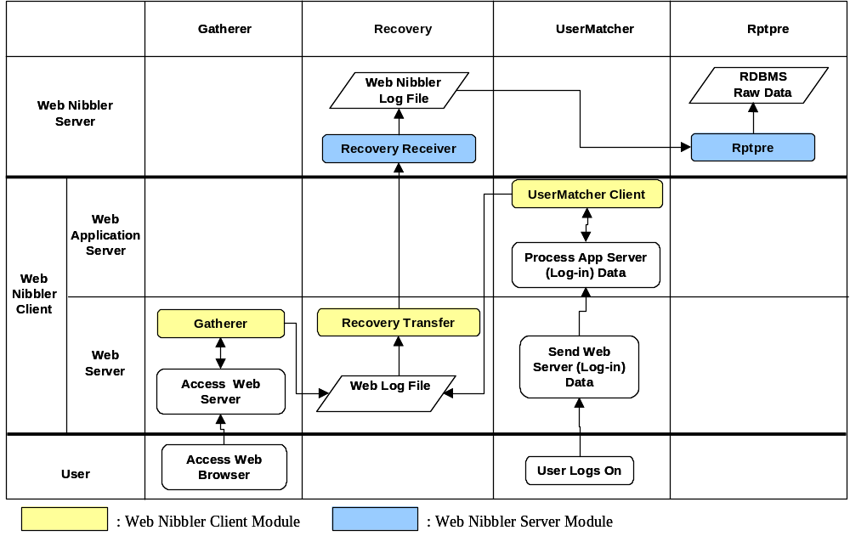

3.8. Workflow of WebNibbler LT

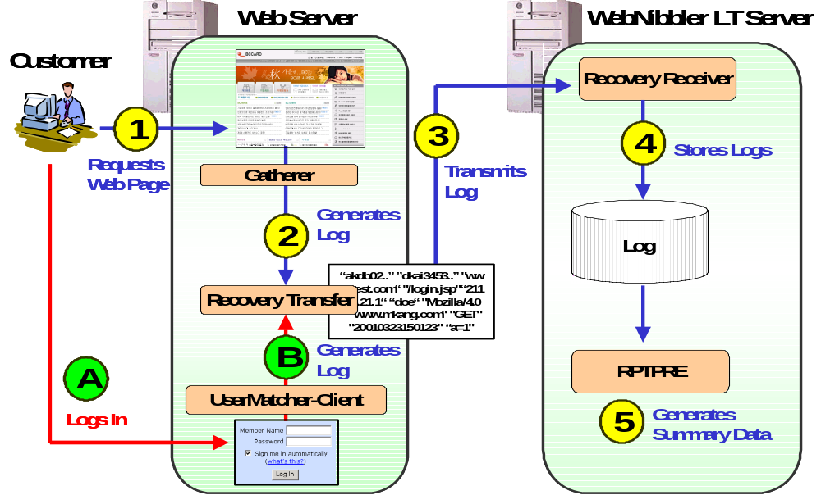
- A user accesses your Website and requests a page or content.
- Gatherer generates a log and save it on the hard disk.
  - At some point of time, the user logs on.
  - UserMatcher-Client collects the login information and optional customer segment data (gender and age); and then generates and saves a log.
- Periodically, Recovery-Transfer sends the accumulated logs to Recovery-Receiver module of WebNibbler LT Server.
- Recovery-Receiver stores the logs in the designated directory on the hard disk.
- Overnight, RPTPre processes the logs and generates summary data that are readily usable for analysis and reports.

4. Preparing Installation
You will be required to install two separate WebNibbler LT components: WebNibbler LT Client on your Web server and WebNibbler LT Server on a computer system where you will be storing and processing the Web logs for analysis.

It doesn’t matter which one you install first. It is, however, recommended to install WebNibbler LT Server first:
Step 1: Install WebNibbler LT Server
Step2: Install WebNibbler LT Client on the Web server.
Step3: If there is more than one Web server, install WebNibbler LT Client on the rest of Web servers, one by one.

Before you begin the installation, please collect or determine the following information, if possible. In the installation process, each item will be explained in detail when applicable.

- System on which WebNibbler-LT Server will be installed.
  - Operating System
  - Amount of free hard disk space
  - Port number for Recovery-Receiver module.

- Web server and Web application server environment:
  - Operating system (e.g. Windows 2000, etc.)
  - Web server type and version (IIS v. 5.0, Apache v. 1.3.12, etc.)
  - The location (file path) of the environment file:
      - For Apache, the file name is: httpd.conf
      - For IIS: not applicable
      - For Netscape or iPlanet: obj.conf
  - Service domain name(s) for your Website
  - Information on the user login page for your Website, if available.
      - The location (file path) of the login page
      - The type of login page (asp or jsp)
  - A method of using UserMatcher function:
      - UserMatcher-Client; or
      - Cookie
  - Amount of free hard disk space

PART II. INSTALLING WEBNIBBLER LT SERVER

In Part II, the installation guide for WebNibbler LT Server is provided.

Summary of Contents
Part III is organized into the following chapters:

- Chapter 1, “Setup for MS Windows 2000/2003,” describes the WebNibbler LT Server installation process for MS Windows 2000/2003.
- Chapter 2, “Setup for Unix/Linux,” describes the WebNibbler LT Server installation process for Unix/Linux.

Chapter 1. Setup For MS Windows 2000 or 2003

Installing WebNibbler LT Server
for
MS Windows 2000 or 2003

Summary of Contents
A. Overview
- System Requirements
- Main Modules of WebNibbler LT Server
- Directories of WebNibbler LT Server

B. Installation
- Begin Installation
- System Requirements
- License Agreement
- Entering Serial Number
- Selecting Destination Directory
- Module Information Setup
- Copying Files
- Installation Completed.

A. Before You Begin
This chapter provides information on how to install WebNibbler LT Server on your Web server and Web Application Server running under Microsoft Windows 2000/2003 environment. The installation process is quite simple and short.

1. System Requirements
Before you install WebNibbler LT Server, make sure your computer system meets the following requirements:

- Microsoft Windows NT 4.0 SP3 or higher
- Microsoft Windows 2000 Server or higher

2. Main Modules of WebNibbler LT Server
The followings are the main modules of WebNibbler LT Server that will be installed.

Module Name | Installed on: | Function
Recovery-Receiver | Management Station System | Receives and saves the Web logs sent by Recovery-Transfer module of WebNibbler LT Client
RPTPre | Management Station System | Processes the log files to generate summary files that can be readily used for analysis and reports. It usually runs once a day overnight. But you can choose the time of execution or execution schedule.

3. Directories of WebNibbler LT Server
After the completion of the installation, you will find the following directories created under the home directory of WebNibble LT Server.

Directory |  |  | Description
Bin |  |  | Contains main executable files of WebNibbler LT Server.
Etc |  |  | Contains the environment file of WebNibbler LT Server.
Inbound |  |  | Contains the log files received from WebNibbler LT Client.
Jre |  |  | Contains the java run time module.
Lib |  |  | Contains the library files of WebNibbler LT Server.
Log |  |  | Records logs of each module of WebNibbler LT Server.
Report | pre | result | Contains the result files of RPTPreext.exe (RPTPre) by date.
Report | pre | Tmp | Is a temporary folder used by RPTPreext.exe (RPTPre).

B. Installation

1. Begin Installation
- Insert the WebNibbler LT Installation CD into the CD-ROM
- Run “Install_WebNibbler_LT_Server.cmd”. This program will install WebNibbler LT Server on your computer.

2. System Requirements
- The system requirements for installing WebNibbler LT Server will be displayed. Please make sure that you have an adequate system.
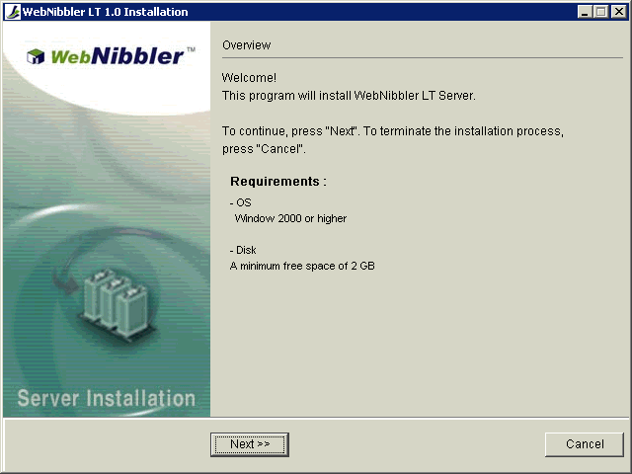
- Press the Next button.

3. License Agreement
- Read the following license agreement. Use the scroll bar to view the rest of agreement.
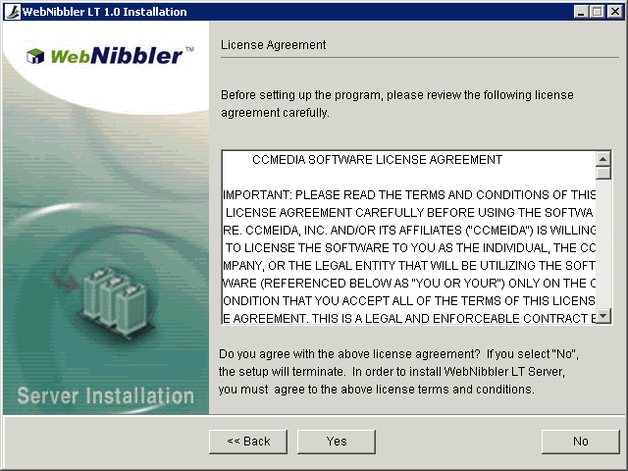
- If you accept the terms, click on the Yes button. If you select No, the installation will be terminated.

4. Entering Serial Number
- Enter your company name and the serial number of WebNibbler LT. If you don’t input the serial number, the program will be installed as a 30 day trial version.
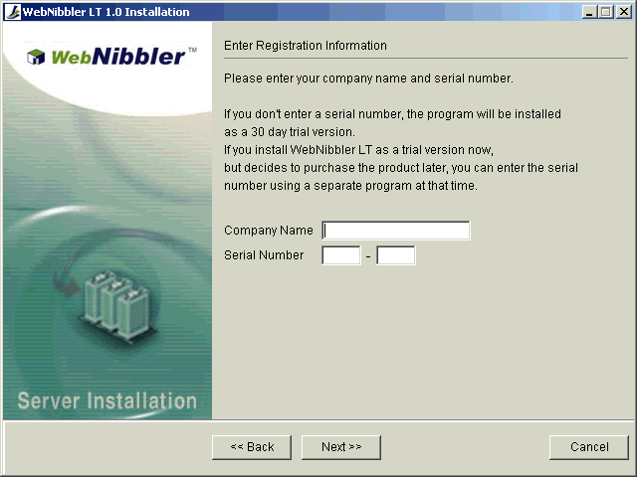
- If you are installing the program as the trial version and purchase the product later, you can register the serial number by running [Home Directory]/bin/RegisterWebNibbler.cmd.

5. Selecting Destination Directory
- Select the destination directory (folder) where you want to install WebNibbler LT Server files. The default directory is c:\ccmedia\webnibbler. If you want to install WebNibbler LT Server files in a different directory, click Browse and select another directory.
- To install to this directory, Press the Next button.
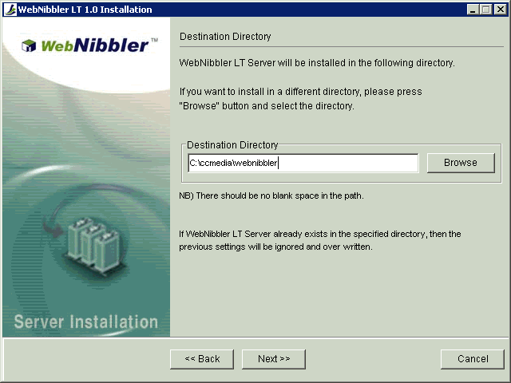

Important: The Destination Directory will be registered in Windows Registry, and the registry information will be used by WebNibbler in its operation. Thus, if you install WebNibbler LT Server manually, or move the location of installed modules to another directory, then you must change the registry information as well.

6. Module Information Setup
- Enter the information required for executing WebNibbler LT Server modules. In this case enter the port number to be used by Recovery-Receiver module. The default is 10021. If this port is being used by another application, enter a port number that is not being used by any other applications.
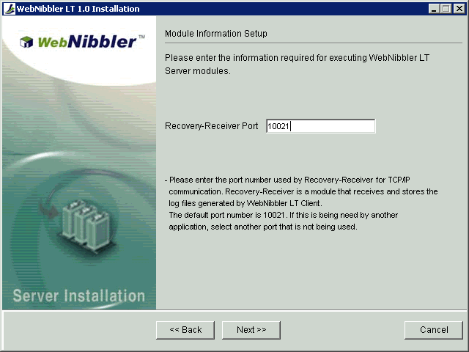
- Press the Next button.

Note: Recovery-Receiver: is a module that receives the logs sent by WebNibbler LT Client and then stores them in ‘inbound’ directory. Recovery-Receiver must be always running. Please write down the port number you entered here. You will need it again when you are asked to provide the port number of Recovery-Receiver during the installation process of WebNibbler LT Client.

7. Copying Files
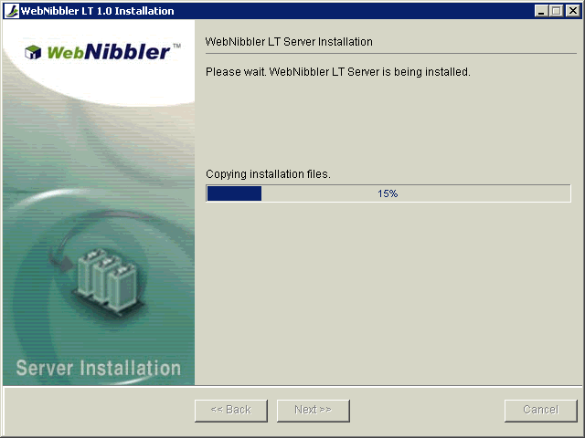
WebNibbler LT Server is now being installed. The directories will be created and the files will be copied to appropriate directories.

8. Installation Completed
- Press the Finish button.
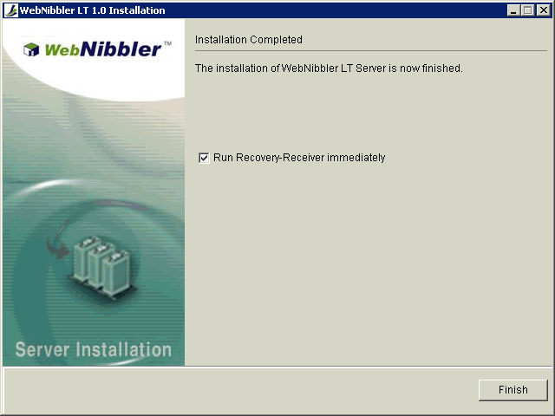
Congratulations! The installation is now completed.

Chapter 2. Setup For Unix or Linux

Installing WebNibbler LT Server
for
Unix or Linux

Summary of Contents
A. Overview
- System Requirements
- Main Modules of WebNibbler LT Server
- Directories of WebNibbler LT Server

B. Installation
- Begin Installation
- License Agreement
- Entering Serial Number
- Entering Destination Directory
- Entering Recovery Receiver Information
- Confirming Installation Information
- Copying Files and Setting Up Environment

A. Overview
This chapter describes how to install WebNibbler LT Server on a system running Unix or Linux. The installation is done manually. However the installation process is very simple.

1. System Requirements
Before you install WebNibbler LT Server, please make sure that your computer system meets the following requirements.
- Operating System
  - Linux RedHat 6.2 or higher;
  - Sun Solaris 2.6 or higher;
  - IBM AIX 4.3.2 or higher;
  - HP Unix 11.0.1 or higher
- Free hard disk space: At least 2 GB.

2. Main Modules of WebNibbler LT Server
The followings are the main modules of WebNibbler LT Server that will be installed on your system.
Module Name | Installed on: | Function
Recovery-Receiver | Management Station System | Receives and saves the Web logs sent by Recovery-Transfer module of WebNibbler LT Client
RPTPre | Management Station System | Processes the log files to generate summary files that can be readily used for analysis and reports. It usually runs once a day overnight. But you can choose the time of execution or execution schedule.

3. Directories of WebNibbler LT Server
After the completion of the installation, you will find the following directories created under the home directory of WebNibble LT Server.

Directory |  |  | Description
Bin |  |  | Contains main executable files of WebNibbler LT Server.
Etc |  |  | Contains the environment file of WebNibbler LT Server.
Inbound |  |  | Contains the log files received from WebNibbler LT Client.
Jre |  |  | Contains the java run time module.
Lib |  |  | Contains the library files of WebNibbler LT Server.
Log |  |  | Records logs of each module of WebNibbler LT Server.
Report | pre | result | Contains the result files of RPTPreext.exe (RPTPre) by date.
Report | pre | Tmp | Is a temporary folder used by RPTPre (RPTPreext.exe).

B. Installation

1. Begin Installation
- Insert the WebNibbler LT Installation CD into the CD-ROM.
- Copy the compressed file, WebNibblerLTServer[OS].tar.gz to your hard disk
- Uncompress the files:
$ gunzip WebNibblerLTServer.[OS].tar.gz
$ tar xvf WebNibblerLTServer.[OS].tar
- Run “Install_WebNibbler_LT_Server.sh”. This program will install WebNibbler LT Server on your computer.

2. License Agreement
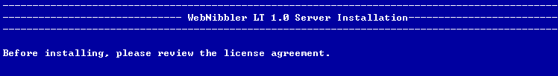
- There is a separate License Agreement file. Open and read it before proceeding.

3. Entering Serial Number
- Enter your company name and the serial number of WebNibbler LT. If you don’t input the serial number, the program will be installed as a 30 day trial version.
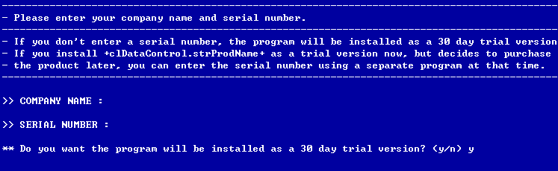
- If you are installing the program as the trial version and purchase the product later, you can register the serial number by running [Home Directory]/bin/RegisterWebNibbler.sh.

4. Entering Destination Directory
- Enter the destination directory where you want to install WebNibbler LT Server directory and files. The default directory is the parent directory of current working directory. If you want to install in the default directory, press the enter key.
Caution: The WebNibbler LT Servrer files will be copied to the directory you enter. Therefore, you must have the “write” privilege for this directory.
Note: The home directory of WebNibbler LT Server will be [Destination Directory]/server.
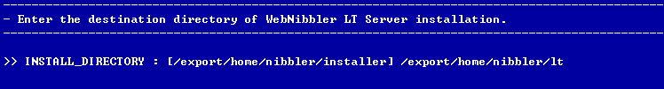
- If the entered directory does not exist, it asks you if you want to create the directory. Press “y” to create the directory and “n” to terminate the installation process.

5. Inputting Recovery Receiver Information
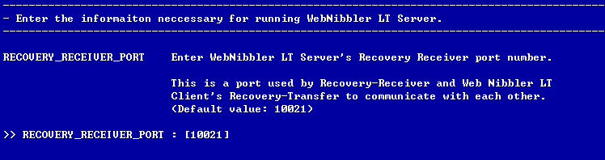
Enter the port number to be used WebNibbler LT Server’s Recovery-Receiver module. The recommended port number is 10021. If the port number 10021 is being used, enter a port number that is not used by any other applications.

Note: Recovery-Receiver: is a module that receives the logs sent by WebNibbler LT Client and then stores them in ‘inbound’ directory. Recovery-Receiver must be always running. Please write down the port number you entered here. You will need it again when you are asked to provide the port number of Recovery-Receiver during the installation process of WebNibbler LT Client.

6. Confirming Installation Information
- What you have entered so far is displayed. Read it to make sure the information is correct.
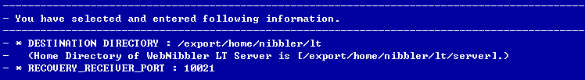

7. Copying Files and Setting up Environment
- You are asked if you want to proceed with the installation to copy the files and set up the environment. Press “y” to proceed and “n” to terminate the installation process.
- The screen will display the processes of copying files and setting up the environment.
- Congratulations! Now, the installation is completed.
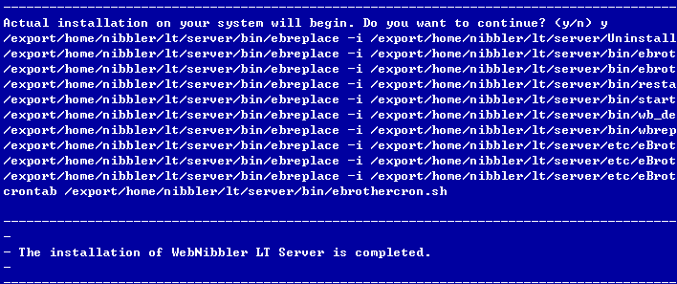

PART III. INSTALLING WEBNIBBLER LT CLIENT

In Part III, the installation guides for WebNibbler LT Client are provided.

Summary of Contents
Part III is organized into the following chapters:

- Chapter 1, “Setup for MS Windows 2000/2003,” describes the WebNibbler LT Client installation process for MS Windows 2000/2003.

- Chapter 2, “Setup for Unix/Linux” describes the WebNibbler LT Client installation process for various versions of Unix and Linux.

Chapter 1. Setup For MS Windows 2000 or 2003

Installing WebNibbler LT Client
for
MS Windows 2000 or 2003

Summary of Contents
A. Before You Begin
- System Requirements
- Main Modules of WebNibbler LT Client

B. Installation
- Begin Installation
- System Requirements
- License Agreement
- Entering Serial Number
- Selecting Modules to Install (Selecting Server Environment)
- Installing The Selected WebNibbler LT Client Modules
6.1. Installing Both Gatherer and UserMatcher-Client
6.2. Installing Gatherer
6.3. Installing UserMatcher-Client

A. Before You Begin

This chapter provides information on how to install WebNibbler LT Client on your Web server and Web Application Server under Microsoft Windows 2000/2003 environment.

You can install WebNibbler LT Client in three different ways depending on your system environment.
- Install both Gatherer and UserMatcher-Client
- Install Gatherer
- Install UserMatcher-Client

1. System Requirements
Before you install WebNibbler LT Client for MS Windows, make sure your computer system meets the following requirements:

- O/S : Microsoft Windows NT 4.0 SP3 or higher
Microsoft Windows 2000 Server or higher
- Web Server:
  - Apache ver. 1.3.xx or higher
  - IIS ver. 5.0 or higher
  - Netscape Server ver. 3.6 or higher
  - iPlanet Server ver. 4.0 or higher
- Free hard disk space: At least 300MB

2. Main Modules of WebNibbler LT Client
The followings are the main modules of WebNibbler LT Client that will be installed.
Module Name | Installed on: | Function
Gatherer | Web Server System | Generates Web logs
UserMatcher-Client | Web App Server System | -Identifies unique anonymous users and authenticated users;  -Matches anonymous user’s data with corresponding registered user’s data;  -Generates customer segmentation data for registered users
Recovery-Transfer | Web Server  Web App Server System | Sends logs to WebNibbler LT Server

B. Installation

1. Begin Installation
- Insert the WebNibbler LT for MS Windows Installation CD into the CD-ROM
- Run “Install_WebNibbler_LT_Client.cmd”. This program will install WebNibbler LT Client on your computer.

2. System Requirements
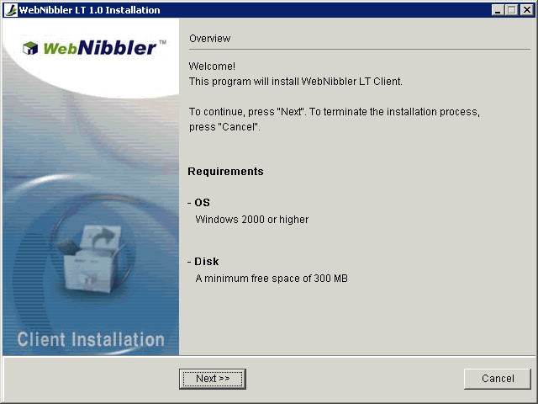
The system requirements for installing WebNibbler LT Client will be displayed. Please make sure that you have an adequate system and then press “Next” button.

3. License Agreement
- Please read the following license agreement. Use the scroll bar to view the rest of agreement.
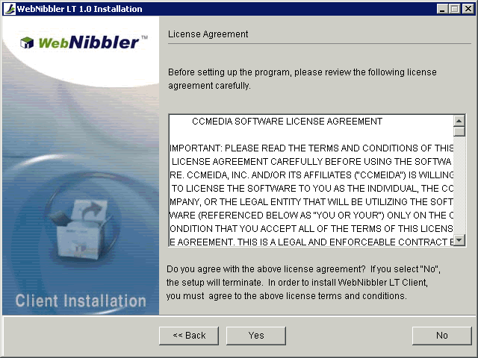
- If you accept the terms, click on the Yes button. If you select No, the installation will be terminated.

4. Entering Serial Number
- Enter your company name and the serial number of WebNibbler LT. If you don’t input the serial number, the program will be installed as a 30 day trial version.
- If you are installing the program as the trial version and purchase the product later, you can register the serial number by running [Home Directory]\bin\RegisterWebNibbler.cmd.
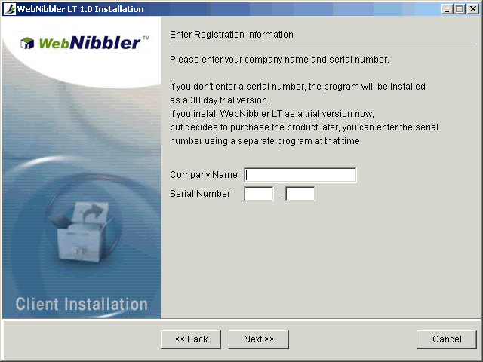

5. Selecting Modules To Install (Selecting Server Environment)
- In the following screen, specify the components of WebNibbler LT Client you want to install. (See below for detail instruction.)
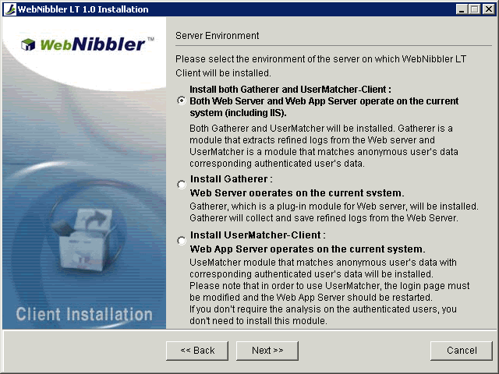
- Press the Next button.

In order to determine which modules to install, check server environment in which WebNibbler LT Client will be installed. WebNibbler LT Client’s Gatherer will be installed on your Web server and WebNibbler LT Client’s UserMatcher-Clienton your Web Appllication Server. According to your system environment, please select an appropriate option to install WebNibbler LT Client.

1. Install both Gatherer and UserMatcher-Client on this system. Both Web Server and Web App Server are operating on this system; or IIS is operating on this system.
If any of the followings is applicable, please select this option.
- Both Web Server and Web App Server are operating on this system; and you provide a Login Service Page to manage online members.
- Your Web server is IIS and the login page is serviced via ASP (Active Server Page).
If you chose this option, go to section “6.1. Installing both Gatherer and UserMatcher”.

2. Install Gatherer only on this system at this time. Web Server is operating on this system.
If any of the followings is applicable, please select this option.
- Login process is not serviced
- Web Server is installed on this system and the login process is handled by Web App Server in a separate server.
- The login process is handled by this system, but you want to install Gatherer only at this time and install User Matcher later separately.
If you chose this option, go to section “6.2. Installing Gatherer”.

3. Install UserMatcher-Client only on this system at this time. Web App Server is currently operating on this system.
If any of the followings is applicable, please select this option.
- You want to install UserMatcher-Client separately now.
- There is Web App Server that handles login service page on this system.
If you chose this option, go to section “6.3. Installing UserMatcher-Client”.

6. Installing Selected WebNibbler LT Client Modules
Based on the selection in the above section “4. Selecting Modules to Install”, go to an appropriate section for the next step:
6.1. Installing Both Gatherer and UserMatcher-Client
6.2. Installing Gatherer
6.3. Installing UserMatcher-Client

6.1. Installing Both Gatherer And UserMatcher-Client
This section will go through the installation process step by step for setting up Gatherer and UserMatcher-Client. The Recovery-Transfer module will be also installed on your Web server by default.

6.1.1. Selecting Destination Directory
- Select the destination directory (folder) where you want to install WebNibbler LT Client files. The default directory is C:\ccmedia\webnibbler. If you want to install WebNibbler LT Client files in a different directory, click Browse and select another directory.
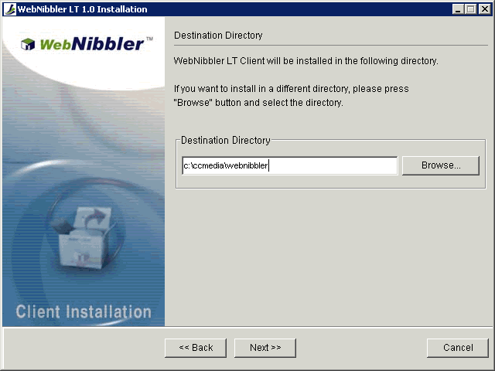
- To install to the selected directory, click the Next button.

Important: The Destination Directory will be registered in Windows Registry, and the registry information will be used by WebNibbler LT in its operation. Thus, if you install WebNibbler LT Client manually, or move the location of installed modules to another directory, then you must change the registry information as well. Also, if necessary, you should restart Web Server and/or Web App Server.

6.1.2. Basic Information Setup
Enter the basic information necessary to install WebNibbler LT Client.
- Select the Web server type.
- Enter the WebNibbler LT Server IP address.
- Enter the Recovery-Receiver port number.
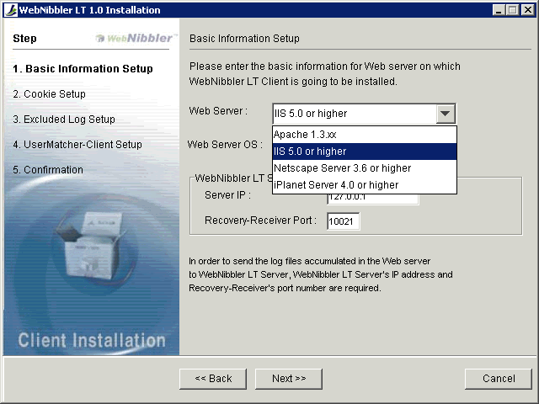
- Press the Next button.

- Web Server
The following is the list of Web servers supported by WebNibbler LT Client:
- Apache ver. 1.3.12 or higher
- IIS ver. 5.0 or higher
- Netscape Server ver. 3.6 or higher
- iPlanet Server ver. 4.0 or higher
- Web Server OS
This particular version of installation program for WebNibbler LT Client supports the Microsoft Windows 2000 and 2003 only.
- WebNibbler LT Server
You are asked to enter the IP address and TCP/IP communication port number for WebNibbler LT Server. These should have been already determined when you installed WebNibbler LT Server.
IP: IP address of WebNibbler LT Server.
Recovery-Receiver Port: The port number used by Recovery-Receiver module of WebNibbler LT Server.
WebNibbler LT Client sends Web logs to WebNibbler LT Server for further processing to generate summarized data used by analysis and reporting tools. Recovery-Transfer is a module of WebNibbler LT Client that sends Web logs to WebNibbler LT Server periodically at scheduled time; and Recover Receiver is a module of WebNibbler LT Server that receives the Web logs. For more information on WebNibbler LT Server, please refer to PART I and PART III of this guide.
- Help
If you need more detailed information on the installation, please press the Help button.

6.1.3. Setting Up Web Server Environment
Now, depending on your selection of the Web server type, go to an appropriate section for explanation on the next step.
6.1.3.1. Apache Environment Setup
6.1.3.2. IIS Environment Setup
6.1.3.3. Netscape/iPlanet Environment Setup

6.1.3.1. Apache Environment Setup
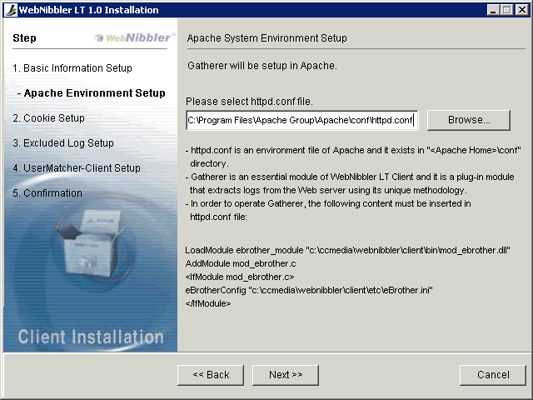
If your Web server is Apache, then the following screen will appear to install Gatherer on the Apache server.
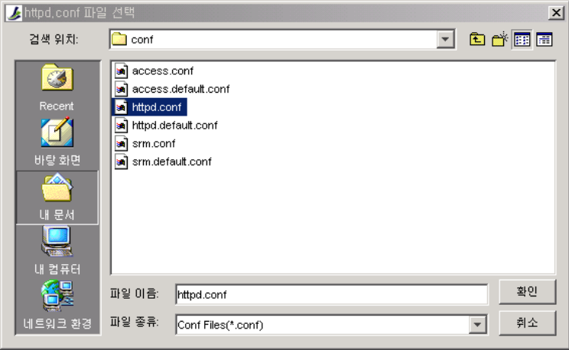
- In the above screen, click on Browse button to locate and select httpd.conf file.

- After the file is selected, press the Next button.
3. Now, go to section 6.1.4. Cookie Information Setup to continue with explanation on the next step of installation.

Important:
As a part of setting up Gatherer on your Apache server, the following lines will be inserted in the Apache’s environment file httpd.conf to plug-in the Gatherer module:
LoadModule ebrother_module “<WebNibbler LT Client Directory>\bin \mod_ebrother.dll”
AddModule mod_ebrother.c
<IfModule mod_ebrother.c>
eBrotherConfig “<WebNibbler LT Client directory>\etc\eBrother.ini”
http.conf will be modified by the installer in the last stage of installation process; and after the completion of installation, you should restart the Apache server.

6.1.3.2. IIS Environment Setup ¨
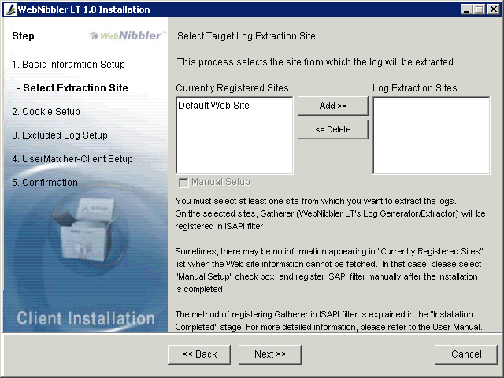
If your Web server is IIS, then the following screen will appear.

The list of sites registered in your IIS Web server will be displayed in the “Currently Registered Sites” box on the left hand side.
- Click on a site on which you want to install Gatherer and extract the Web logs
- Press the Add button.
- Repeat the process 1 and 2, if you have another site to add.
- Press the Next button.
- Now, go to section 6.1.4. Cookie Information Setup to continue with explanation on the next step of installation.

Important: After the completion of WebNibbler LT Client installation, Gatherer will be registered in the ISAPI filters. Please note that if you delete or change WebNibbler LT’s registry data in Windows Registry, a critical error may occur.

6.1.3.3. Netscape/iPlanet Environment Setup
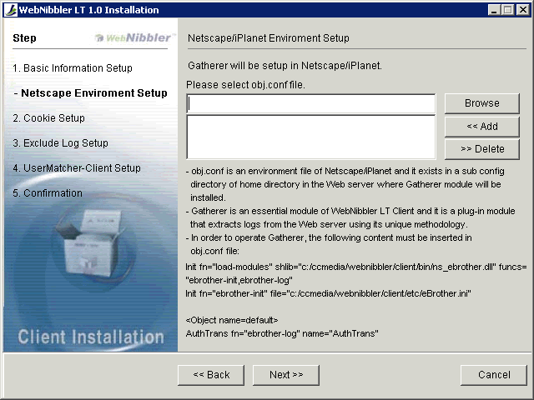
If your Web server is either Netscape or iPlanet, then the following screen will appear.

- Click on Browse button to find and select the Netscape/iPlanet server’s environment file, obj.conf.
- Then, press the Add button.
- If there is another Website/Web server on this system, repeat the process 1 and 2 to select and add every obj.conf files.
- Press the Next button.

Important: As a part of setting up Gatherer on your Netscape/iPlanet server, the Netscape/iPlanet server’s environment file httpd.conf will be modified to insert the following lines to plug-in Gatherer:
A. For Nescape
The Installer program adds the following in the file obj.conf automatically.
Init fn=”load modules” shlib=”<WebNibbler LT Client directory>\bin\ns_ebrother.dll” funcs=”ebrother-init,ebrother-log”
Init fn=“ebrother-init” file=”< WebNibbler LT Client directory >\etc\eBrother.ini”
<Object name=default>
AuthTrans fn=“ebrother-log” name=”AuthTrans”

B. For iPlanet
The Installer program adds the followings in the file magnus.conf automatically.
Init fn=”load modules” shlib=”< WebNibbler LT Client directory >\bin\ns_ebrother.dll” funcs=”ebrother-init,ebrother-log”
Init fn=“ebrother-init” file=”< WebNibbler LT Client directory >\etc\eBrother.ini”

Also, the followings are inserted in the file obj.conf.
<Object name=default>
AuthTrans fn=“ebrother-log” name=”AuthTrans”

The files will be modified by the installer in the last stage of the installation process. After the completion of installation, your Netscape/iPlanet server should be restarted.

6.1.4. Cookie Information Setup
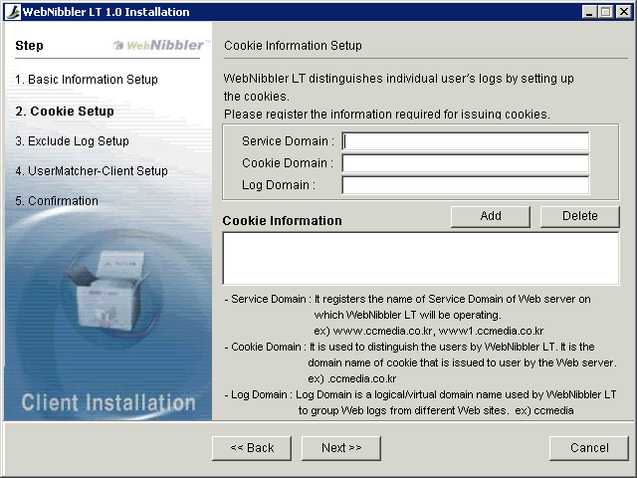
Now, the following screen will appear to setup information on the cookies that will be issued to the Web visitor’s PC browser by WebNibbler LT.

- Enter the cookie information, namely your Website’s Service Domain, Cookie Domain, and Log Domain. After entering the Service Domain, press the Enter key. Default values for Cookie Domain and Log Domain will appear automatically. If necessary, change the values. You must register at least one set of cookie information. The explanation on these three items is provided below.
- Press the Add button.
- If there is another Service Domain, repeat the process 1 and 2.
- Press the Next button.

If you want to delete a cookie information already registered, then select the information in the Cookie Information box and press the Delete button.
Please note that you cannot have ‘/’ character in the domain names.

Explanation
Service Domain: Enter the service domain name of the Website from which you want to collect Web logs via Gatherer. (ex: www.ccmedia.com, shopping.ccmedia.com, www1.ccmedia.com). Service Domain is very important information for operation of Gatherer. If your Website is not registered as a Service Domain here, the Web logs won’t be collected even if the Gatherer module is installed on the Website.
Cookie Domain: Cookie Domain is the same as Domain Host Header. Enter the name of domain from which cookie will be issued to identify the users by WebNibbler. (ex: .ccmedia.com)
Log Domain: Log Domain is a logical/virtual domain name used by WebNibbler LT to group Websites to integrate Web logs from different Websites in analysis. (ex: ccmedia).

Example:
Suppose you have three Web service domains: www.ccmedia.com, shopping.ccmedia.com, www1.ccmedia.com.
Then Cookie Domain is “.ccmedia.com” for all three sites.
By default, the Log Domain is .ccmedia for all three sites. In the log analysis, all three sites will be treated as one for integrated analysis. Of course, you can still perform analysis on each site separately as well. If you assign “.ccmedia” to the Log Domain for www.ccmedia.com and www1.ccmedia.com; and “.shopping” for shopping.ccmedia.com, then you will have two sets of integrated logs: one for “.ccmeida” and the other for “.shopping”.
For more information, please refer to the table below.
Item | Description | Example
Service Domain | The domain name of Web server on which WebNibbler LT Client will be operating. For example, in the URL address, http://www.ccmedia.com/index.jsp, the Service Domain is www.ccmedia.com.  If you use an IP address to provide the Web service, then you may register the IP address instead. | www.ccmedia.com  www1.ccmedia.com  www2.ccmedia.com  127.0.0.1
Cookie Domain | Cookie Domain is used to distinguish the users. It is the domain name of the cookies issued by the Web server. In general, if the Service Domain name is “www.ccmedia.com” then the Cookie Domain is “.ccmedia.com”.  If you use an IP address to provide the Web service, then you may register the IP address instead. | .ccmedia.com  127.0.0.1
Log Domain | The Log Domain is used to integrate Web logs logically. For example, when there are more than one Service Domain, if you assign a same Log Domain name to all Service Domains, their Web logs can be treated as a log from a single site instead of multiple sites. This is useful if you provide the Web services through several Service Domains and want to perform integrated analysis throughout the sites.  If you use an IP address to provide the Web service, then you may register the IP address instead. | Ccmedia  127.0.0.1

6.1.5. Excluded Log Setup (Log Filtering)
- Enter the type of log data to be filtered out in gathering log in the Add Log Data to be Excluded box..
- Press the Add button.
- Repeat the process 1 and 2 if you have more files to filter out in the log collection process.
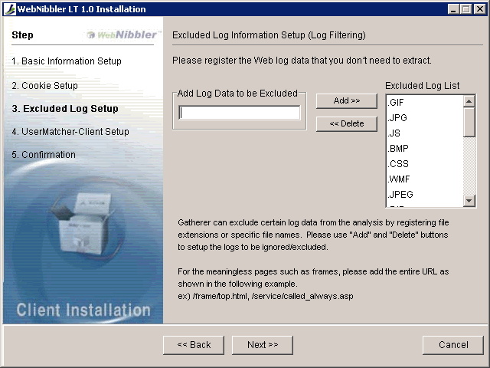
- Press the Next button.

There are certain file types or files that are meaningless in the log analysis, such as graphic image files and frames. Determine which files you want to exclude in the log analysis. For a file type, enter the file extension; and for a specific file, enter the exact file path and name. (Ex. /frame/top.asp)
There are certain file types provided as defaults in the Excluded Log List box on the right hand side. Specifically, the files with the following file extensions will be ignored in the log collection process by default: GIF, JPG, JS, BMP, CSS, WMF, JPEG, DIB, CLASS, JIF, RLE, PCD, PCX, PIC, PNG, PSD, TGA, TIF, TIFF, TXT, ICO.
If you don’t want to exclude any of these file types, select it and then press Delete.
The Excluded Log List does not distinguish between capital letters and small letters (i.e., not case sensitive.)

6.1.6. UserMatcher-Client Setup
- Select the UserMatcher process type: either UserMatcher-Client module or Cookie.
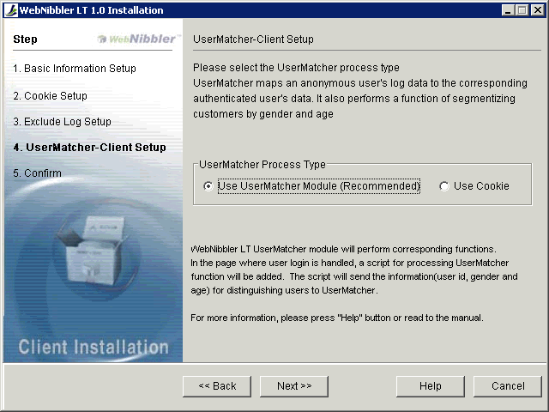
- Press the Next button.

Here, you are entering the information required to install a UserMatcher feature. The UserMatcher feature performs a function of mapping an anonymous user’s records to corresponding registered member’s records when the user logs in.
There are two ways of using UserMatcher feature: using the UserMatcher-Client module and using cookies.

- Use UserMatcher-Client Module (Recommended)
The UserMatcher-Client module is used to obtain an authenticated user’s mapping data and customer segmentation data. The obtained data is stored in a file under WebNibbler LT’s subdirectory “inbound”.

- Use Cookies
This method utilizes a session cookie named “ccmedia” which contains the member’s login ID, gender and age. In order to use this method, it must be possible to issue the cookie from the login page. If, for security reasons or any other reason, the cookie cannot be issued, then please use User Matcher module instead.

If you are unsure which one to use, choose the “Use UserMatcher-Client Module” option.

In order to execute UserMatcher, a certain script must be inserted in your login page manually to execute UserMatcher-Client fucntion. This is done later while UserMatcher-Client is being installed after the installation of Gatherer is completed. For more information, please refer to “Installing UserMatcher” section in 6.1.10 in this chapter.

6.1.7. Confirmation
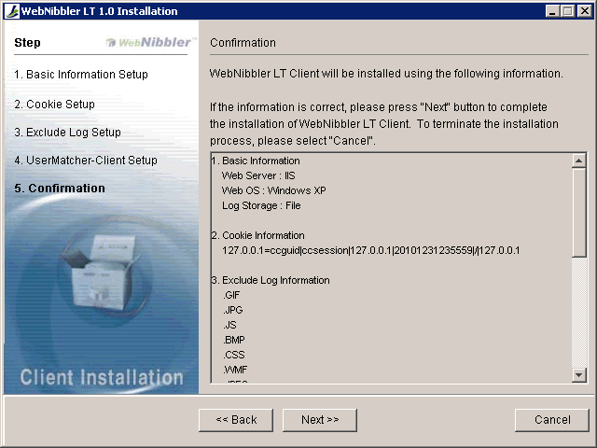
The following screen will appear to confirm the Setup options selected so far.

If the information is correct, press Next to proceed with the installation. If you want to make changes, press the Back button to go back to the previous screen.

6.1.8. Copying Files
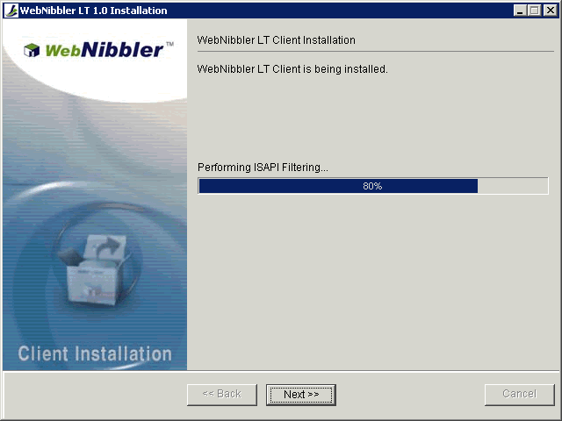
Gatherer is now being installed. The directories will be created and the files will be copied to appropriate directories.

6.1.9. Completion of Gatherer Installation
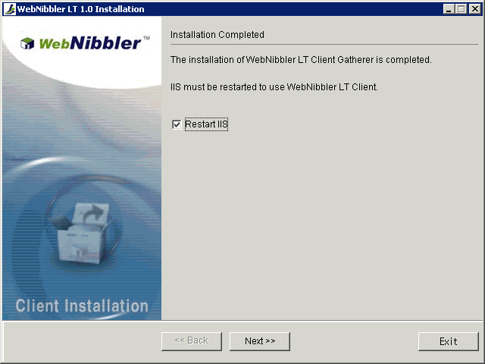
The installation of Gatherer is now completed.

- Checkmark the “Restart Web Server” box.
- Press the Next button.

After restarting the Web Server, the UserMatcher-Client installation process will begin.
If you press Exit instead of Next, the installation process for UserMatcher-Client will be terminated after restarting the Web server.
If it’s not an appropriate time to restart the Web server now for any reason, uncheck the Restart Web server box and then press Next to proceed with the installation of UserMatcher-Client.

Important: Gatherer may not operate properly if you don’t restart the Web server. It is recommended to restart the Web server at this time.

6.1.10. Understanding UserMatcher-ClientEnvironment Setup
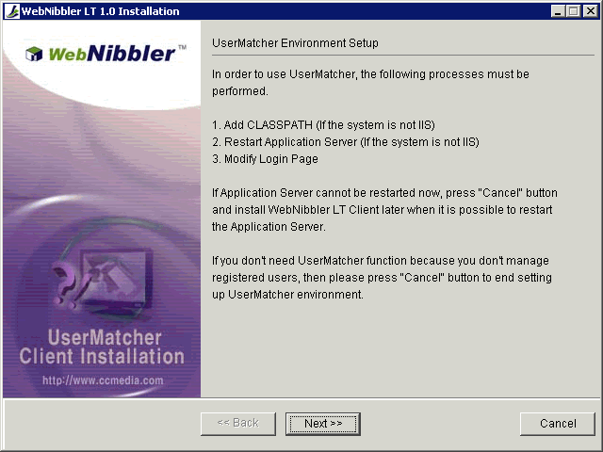
The installation of UserMatcher-Client will begin. Please make sure that you have a clear understanding of your Web Application Server before proceeding, or consult your system administrator. ¨Incorrect installation may cause problems in your Web services.

In the process of installing UserMatcher-Client on your Web App Server, you will have to perform the followings to modify your Web App Server:
- If your Web server is IIS:
- Insert UserMatcher-Clientscripts in your login service page (for interoperation between the login page and UserMatcher-Client)
- If your Web server is Apache, Netscape or iPlanet:
- Insert codes in CLASSPATH (so that Web Application Server will recognize the UserMatcher-Client module.)
- Restart Web Application Server
- Insert UserMatcher-Clientscripts in your login service page (for interoperation between the login page and UserMatcher-Client)
- If your Web Server is IIS and you use a separate Web Application Server to provide the login page service:
- This is not supported by the Installation program. You will need to perform some manual work to have your Web App Server interoperate with UserMatcher-Client based on the information provided in 6.1.11 and 6.1.12. If you need an assistance, please contact CCMedia or its authorized distributors.

6.1.11. Adding Classpath
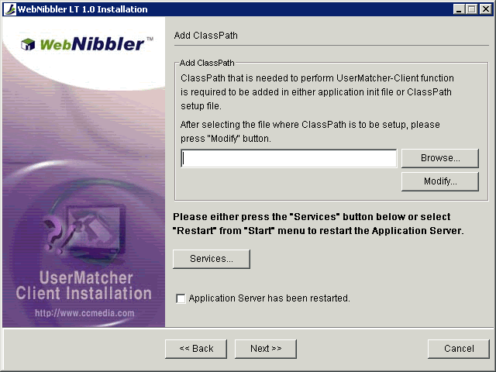
If your server is IIS, then skip this section and go to the next section 6.1.12.
In the Web App Server’s classpath, UserMatcher-Client classpath will be added.

- Press Browse to select the file whereby you can add the classpath.
- Then press Modify.
- The following screen will appear to let you edit the selected file. The text in the box at bottom must be inserted in the file. Select and copying the entire text in the box at the bottom.
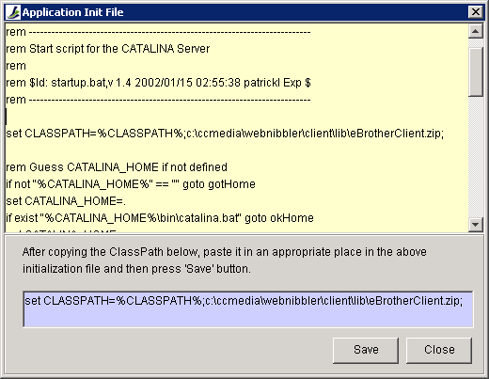
- Paste it in an appropriate spot in the file displayed in the upper box.

- Press Save.
- Press Close.
- Restart the Web Application Server now. Otherwise, WebNibbler LT may not operate properly. You may press the Services button to restart the Web App Server (WAP) from Windows Service Manager, if WAP can be controlled from Web Service Manager. If not, go to WAP directory and restart it.
- Checkmark the “Application server has been restarted” box
- Press the Next button.

6.1.12. Modifying Login Page
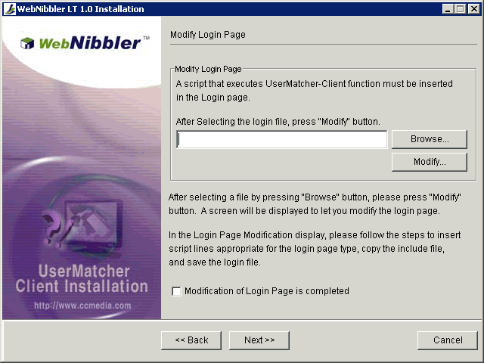
This process will insert a script in your login service page in order to communicate with UserMatcher.

- Press Browse to select the file for login service page on your Website.
- Then press Modify.
- The following screen will appear to let you modify the selected file.

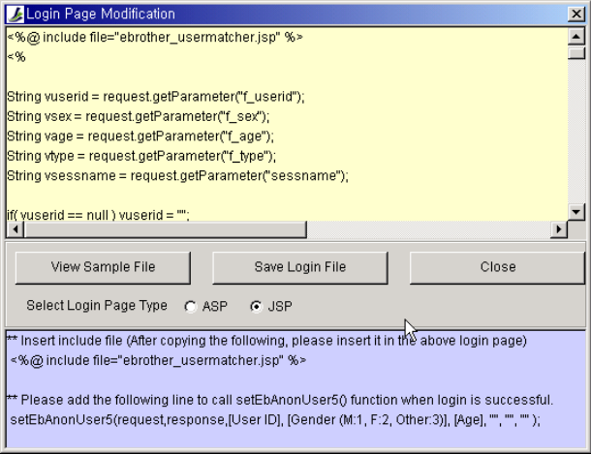
① Selected Login Page
② Scripts to be inserted in the login page

- If you chose to use the UserMatcher-Client module instead of Cookies in the section “6.1.6. UserMatcher-Client Setup”:
- Select whether the type of login page is ASP (Active Server Page) or JSP (Java Server Page). Depending on the selection, the appropriate scripts to be inserted will appear in the box at the bottom of screen as shown in the above picture.
- Copy the content in the box at the bottom, and then insert it into the login page by pasting it in an appropriate place in the login page as explained below. Because every company has different login page formats, you must make your own judgment to determine where you should insert the scripts.
  - If the login page is a Java Server Page (JSP):
    - Copy and paste the following code to call the include file in an appropriate place. This usually is a place where you find other scripts for include files.
<%@ include file="ebrother_usermatcher.jsp" %>
    - Copy and paste the following script in the login page immediately below the script line that successfully finishes the login process. This script calls the UserMatcher-Client function.
setEbAnonUser5(“[user ID]”,“[Gender Code]”,”[Age]”,“”,“”,“”)

  - If the login page is an Active Server Page (ASP).
    - Copy and paste the following code in an appropriate place. This usually is a place where you find other scripts for include files.
<!--#include file="ebrother_usermatcher.asp" -->
    - Copy and paste the following script in the login page immediately below the script line that successfully finishes the login process. This script calls the UserMatcher-Client function.
setEbAnonUser5(“[user ID]”,“[Gender Code]”,”[Age]”,“”,””,””)

Important: you have to replace User ID, Gender Code and Age with the variables you actually use in your login page script. If you don’t have Gender Code and Age data, then you may leave them blank. If you leave them blank, however, you wouldn’t be able to use customer segmentation feature of WebNibbler LT.
What is setEbAnonUser5?
setEbAnonUser5 is a function defined as an Include File. It is an essential function of UserMatcher-Client. It matches anonymous user with corresponding registered member and handles customer segmentation data (i.e. Gender and Age)
The parameters of the function are as follows:
User ID: User ID is a mandatory data and it passes the user’s login ID.
Gender Code: In general, male=1, female=2, others including corporate membership=3. If you don’t handle the gender information in the current login page, modify your login page to fetch the gender information. If it is not possible to fetch the gender information, then leave it as a blank. If you leave the Gender Code as a blank, then you won’t be able to produce analysis reports by gender.
Age: User’s age (up to 3 digits). If you cannot fetch the age data, then leave it as a blank. However, if you leave it a blank, you won’t be able to produce analysis reports by age.
- After modifying the login page, press the [Save Login File] button to apply the changes. The include file (ebrother_usermatcher.asp or ebrother_usermatcher.jsp) will be copied immediately to the directory where the login page exists.
- Checkmark the “Login Page Modification Completed” box
- Press Next.

- If you chose to use Cookies instead of UserMatcher-Client in the section “6.1.6. UserMatcher-Client Setup”:
- Copy and paste the following script line in the login page to issue a Session Cookie. It should be inserted at the line immediately below the script that processes the user login successfully.

  - If the login page is a Java Server Page:
response.setHeader(“Set-Cookie”, “ccmedia=”+”[User_ID]” + ”_/” + ”[Gender_Code]” + "_/" + ”[Age]” );

  - If the login page is an Active Server Page:
Response.Cookies(“ccmedia”)=“[User_ID]”&"_/"&“[Gender_Code]”&"_/" “[Age]”

- Checkmark the “Login Page Modification Completed” box.
- Press Next.

- View Sample File
For more information on the login page modification, please review the sample file that handles UserMatcher-Client by pressing [View Sample File].

6.1.13. Setup Completed
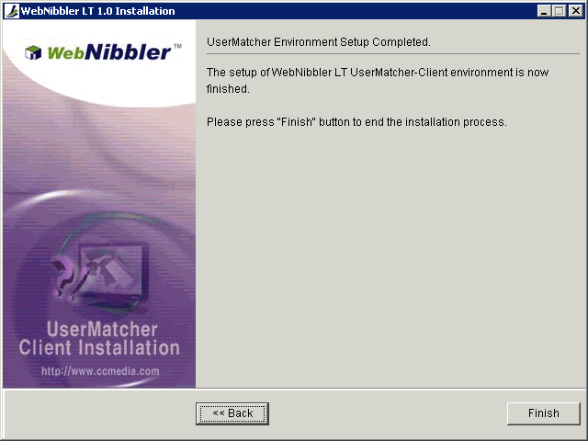
Congratulations! The installation is now completed. Press the Finish button.

6.2. Installing Gatherer
This section will go through the installation process step by step for setting up Gatherer. The Recovery-Transfer module will be also installed on your Web server by default.

6.2.1. Selecting Destination Directory

- Select the destination directory (folder) where you want to install WebNibbler LT Client files. The default directory is C:\ccmedia\webnibbler. If you want to install WebNibbler LT Client files in a different directory, click Browse and select another directory.
- To install to the selected directory, click the Next button.

Important: The Destination Directory will be registered in Windows Registry, and the registry information will be used by WebNibbler in its operation. Thus, if you install WebNibbler LT Client manually, or move the location of installed modules to another directory, then you must change the registry information as well. Also, if necessary, you should restart Web Server and/or Web App Server.

6.2.2. Basic Information Setup
Enter the basic information necessary to install WebNibbler LT Client.
- Select the Web server type.
- Enter the WebNibbler LT Server IP address.
- Enter the Recovery-Receiver port number.
- Press the Next button.

- Web Server
The following is the list of Web servers supported by WebNibbler LT Client:
- Apache ver. 1.3.12 or higher
- IIS ver. 5.0 or higher
- Netscape Server ver. 3.6 or higher
- iPlanet Server ver. 4.0 or higher

- Web Server OS
This particular version of installation program for WebNibbler LT Client supports the Microsoft Windows 2000 and 2003 only.

- WebNibbler LT Server
You are asked to enter the IP address and TCP/IP communication port number for WebNibbler LT Server. These should have been already determined when you installed WebNibbler LT Server.

IP: Enter IP address of WebNibbler LT Server.
Recovery-Receiver Port: Enter the port number to be used by Recovery-Receiver module of WebNibbler LT Server.

WebNibbler LT Client sends Web logs to WebNibbler LT Server for further processing to generate summarized data used by analysis and reporting tools. Recovery-Transfer is a module of WebNibbler LT Client that sends Web logs to WebNibbler LT Server periodically at scheduled time; and Recover Receiver is a module of WebNibbler LT Server that receives the Web logs. For more information on WebNibbler LT Server, please refer to PART I and PART III of this guide.

- Help
If you need more detailed information on the installation, please press the Help button.

6.2.3. Setting Up Web Server Environment
Now, depending on your selection of the Web server type, go to an appropriate section for explanation on the next step.
6.2.3.1. Apache Environment Setup
6.2.3.2. IIS Environment Setup
6.2.3.3. Netscape/iPlanet Environment Setup

6.2.3.1. Apache Environment Setup
If your Web server is Apache, then the following screen will appear to install Gatherer on the Apache server.

- In the above screen, click on Browse button to locate and select httpd.conf file.

- After the file is selected, press the Next button.
- Now, go to section 6.2.4. Cookie Information Setup to continue with explanation on the next step of installation.

Important:
As a part of setting up Gatherer on your Apache server, the following lines will be inserted in the Apache’s environment file httpd.conf to plug-in the Gatherer module:
LoadModule ebrother_module “<WebNibbler LT Client Directory>\bin \mod_ebrother.dll”
AddModule mod_ebrother.c
<IfModule mod_ebrother.c>
eBrotherConfig “<WebNibbler LT Client directory>\etc\eBrother.ini”
http.conf will be modified by the installer in the last stage of installation process; and after the completion of installation, you should restart the Apache server.

6.2.3.2. IIS Environment Setup ¨
If your Web server is IIS, then the following screen will appear.

The list of sites registered in your IIS Web server will be displayed in the “Currently Registered Sites” box on the left hand side.
- Click on a site on which you want to install Gatherer and extract the Web logs
- Press the Add button.
- Repeat the process 1 and 2, if you have another site to add.
- Press the Next button.
- Now, go to section 6.2.4. Cookie Information Setup to continue with explanation on the next step of installation.

Important: After the completion of WebNibbler LT Client installation, Gatherer will be registered in the ISAPI filters. Please note that if you delete or change WebNibbler LT’s registry data in Windows Registry, a critical error may occur.

6.2.3.3. Netscape/iPlanet Environment Setup
If your Web server is either Netscape or iPlanet, then the following screen will appear.

- Click on Browse button to find and select the Netscape/iPlanet server’s environment file, obj.conf.
- Then, press the Add button.
- If there is another Website/Web server on this system, repeat the process 1 and 2 to select and add every obj.conf files.
- Press the Next button.

Important: As a part of setting up Gatherer on your Netscape/iPlanet server, the Netscape/iPlanet server’s environment file httpd.conf will be modified to insert the following lines to plug-in Gatherer:
A. For Nescape
The Installer program adds the following in the file obj.conf automatically.
Init fn=”load modules” shlib=”<WebNibbler LT Client directory>\bin\ns_ebrother.dll” funcs=”ebrother-init,ebrother-log”
Init fn=“ebrother-init” file=”< WebNibbler LT Client directory >\etc\eBrother.ini”
<Object name=default>
AuthTrans fn=“ebrother-log” name=”AuthTrans”

B. For iPlanet
The Installer program adds the followings in the file magnus.conf automatically.
Init fn=”load modules” shlib=”< WebNibbler LT Client directory >\bin\ns_ebrother.dll” funcs=”ebrother-init,ebrother-log”
Init fn=“ebrother-init” file=”< WebNibbler LT Client directory >\etc\eBrother.ini”

Also, the followings are inserted in the file obj.conf.
<Object name=default>
AuthTrans fn=“ebrother-log” name=”AuthTrans”

The files will be modified by the installer in the last stage of the installation process. After the completion of installation, your Netscape/iPlanet server should be restarted.

6.2.4. Cookie Information Setup
Now, the following screen will appear to setup information on the cookies that will be issued to the Web visitor’s PC browser by WebNibbler LT.

- Enter the cookie information, namely your Website’s Service Domain, Cookie Domain, and Log Domain. After entering the Service Domain, press the Enter key. Default values for Cookie Domain and Log Domain will appear automatically. If necessary, change the values. You must register at least one set of cookie information. The explanation on these three items is provided below.
- Press the Add button.
- If there is another Service Domain, repeat the process 1 and 2.
- Press the Next button.

If you want to delete a cookie information already registered, then select the information in the Cookie Information box and press the Delete button.
Please note that you cannot have ‘/’ character in the domain names.

Explanation
Service Domain: Enter the service domain name of the Website from which you want to collect Web logs via Gatherer. (ex: www.ccmedia.com, shopping.ccmedia.com, www1.ccmedia.com). Service Domain is very important information for operation of Gatherer. If your Website is not registered as a Service Domain here, the Web logs won’t be collected even if the Gatherer module is installed on the Website.
Cookie Domain: Cookie Domain is the same as Domain Host Header. Enter the name of domain from which cookie will be issued to identify the users by WebNibbler. (ex: .ccmedia.com)
Log Domain: Log Domain is a logical domain name used by WebNibbler to group Websites to integrate Web logs from different Websites in analysis. (ex: ccmedia).

Example:
Suppose you have three Web service domains: www.ccmedia.com, shopping.ccmedia.com, www1.ccmedia.com.
Then Cookie Domain is “.ccmedia.com” for all three sites.
By default, the Log Domain is .ccmedia for all three sites. In the log analysis, all three sites will be treated as one for integrated analysis. Of course, you can still perform analysis on each site separately as well. If you assign “.ccmedia” to the Log Domain for www.ccmedia.com and www1.ccmedia.com; and “.shopping” for shopping.ccmedia.com, then you will have two sets of integrated logs: one for “.ccmeida” and the other for “.shopping”.
For more information, please refer to the table below.
Item | Description | Example
Service Domain | The domain name of Web server on which WebNibbler LT Client will be operating. For example, in the URL address, http://www.ccmedia.com/index.jsp, the Service Domain is www.ccmedia.com.  If you use an IP address to provide the Web service, then you may register the IP address instead. | www.ccmedia.com  www1.ccmedia.com  www2.ccmedia.com  127.0.0.1
Cookie Domain | Cookie Domain is used to distinguish the users. It is the domain name of the cookies issued by the Web server. In general, if the Service Domain name is “www.ccmedia.com” then the Cookie Domain is “.ccmedia.com”.  If you use an IP address to provide the Web service, then you may register the IP address instead. | .ccmedia.com  127.0.0.1
Log Domain | The Log Domain is used to integrate Web logs logically. For example, when there are more than one Service Domain, if you assign a same Log Domain name to all Service Domains, their Web logs can be treated as a log for a single site instead of multiple sites. This is useful if you provide the Web services through several Service Domains and want to perform integrated analysis throughout the sites.  If you use an IP address to provide the Web service, then you may register the IP address instead. | Ccmedia  127.0.0.1

6.2.5. Excluded Log Setup (Log Filtering)
- Enter the type of log data to be filtered out in gathering log in the Add Log Data to be Excluded box..
- Press the Add button.
- Repeat the process 1 and 2 if you have more files to filter out in the log collection process.
- Press the Next button.

There are certain file types or files that are meaningless in the log analysis, such as graphic image files and frames. Determine which files you want to exclude in the log analysis. For a file type, enter the file extension; and for a specific file, enter the exact file path and name. (Ex. /frame/top.asp)
There are certain file types provided as defaults in the Excluded Log List box on the right hand side. Specifically, the files with the following file extensions will be ignored in the log collection process by default: GIF, JPG, JS, BMP, CSS, WMF, JPEG, DIB, CLASS, JIF, RLE, PCD, PCX, PIC, PNG, PSD, TGA, TIF, TIFF, TXT, ICO.
If you don’t want to exclude any of these file types, select it and then press Delete.
The Excluded Log List does not distinguish between capital letters and small letters.

6.2.6. Confirmation
The following screen will appear to confirm the Setup options selected so far.

If the information is correct, press Next to proceed with the installation. If you want to make changes, press the Back button to go back to the previous screen.

6.2.7. Copying Files
Gatherer is now being installed. The directories will be created and the files will be copied to appropriate directories.

6.2.8. Completion of Gatherer Installation
The installation of Gatherer is now completed.

- Checkmark the “Restart Web Server” box.
- Press the Next button.

If it’s not an appropriate time to restart the Web server now for any reason, uncheck the Restart Web server box and then press Next to proceed with the installation of UserMatcher-Client.

Important: Gatherer may not operate properly if you don’t restart the Web server. It is recommended to restart the Web server at this time.

6.3. Installing UserMatcher-Client
This section will go through the installation process step by step for setting up UserMatcher-Client.

6.3.1. Selecting Destination Directory

- Select the destination directory (folder) where you want to install WebNibbler LT Client files. The default directory is C:\ccmedia\webnibbler. If you want to install WebNibbler LT Client files in a different directory, click Browse and select another directory.
- To install to the selected directory, click the Next button.

Important: The Destination Directory will be registered in Windows Registry, and the registry information will be used by WebNibbler LT in its operation. Thus, if you install WebNibbler LT Client manually, or move the location of installed modules to another directory, then you must change the registry information as well. Also, if necessary, you should restart Web Server and Web App Server.

6.3.2. Cookie Information Setup
Now, the following screen will appear to setup information on the cookies that will be issued to the Web visitor’s PC browser by WebNibbler LT.

- Enter the cookie information, namely your Website’s Service Domain, Cookie Domain, and Log Domain. After entering the Service Domain, press the Enter key. Default values for Cookie Domain and Log Domain will appear automatically. If necessary, change the values. You must register at least one set of cookie information. The explanation on these three items is provided below.
- Press the Add button.
- If there is another Service Domain, repeat the process 1 and 2.
- Press the Next button.

If you want to delete a cookie information already registered, then select the information in the Cookie Information box and press the Delete button.
Please note that you cannot have ‘/’ character in the domain names.

Explanation

Service Domain: Enter the service domain name of the Website from which you want to collect Web logs via Gatherer. (ex: www.ccmedia.com, shopping.ccmedia.com, www1.ccmedia.com). Service Domain is very important information for operation of Gatherer. If your Website is not registered as a Service Domain here, the Web logs won’t be collected even if the Gatherer module is installed on the Website.
Cookie Domain: Cookie Domain is the same as Domain Host Header. Enter the name of domain from which cookie will be issued to identify the users by WebNibbler. (ex: .ccmedia.com)
Log Domain: Log Domain is a logical domain name used by WebNibbler LT to group different Websites to integrate their Web logs Websites in analysis. (ex: ccmedia).

Example:
Suppose you have three Web service domains: www.ccmedia.com, shopping.ccmedia.com, www1.ccmedia.com.
Then Cookie Domain is “.ccmedia.com” for all three sites.
By default, the Log Domain is .ccmedia for all three sites. In the log analysis, all three sites will be treated as one for integrated analysis. Of course, you can still perform analysis on each site separately as well. If you assign “.ccmedia” to the Log Domain for www.ccmedia.com and www1.ccmedia.com; and “.shopping” for shopping.ccmedia.com, then you will have two sets of integrated logs: one for “.ccmeida” and the other for “.shopping”.
For more information, please refer to the table below.
Item | Description | Example
Service Domain | The domain name of Web server on which WebNibbler LT Client will be operating. For example, in the URL address, http://www.ccmedia.com/index.jsp, the Service Domain is www.ccmedia.com.  If you use an IP address to provide the Web service, then you may register the IP address instead. | www.ccmedia.com  www1.ccmedia.com  www2.ccmedia.com  127.0.0.1
Cookie Domain | Cookie Domain is used to distinguish the users. It is the domain name of the cookies issued by the Web server. In general, if the Service Domain name is “www.ccmedia.com” then the Cookie Domain is “.ccmedia.com”.  If you use an IP address to provide the Web service, then you may register the IP address instead. | .ccmedia.com  127.0.0.1
Log Domain | The Log Domain is used to integrate Web logs logically. For example, when there are more than one Service Domain, if you assign a same Log Domain name to all Service Domains, their Web logs can be treated as a log for a single site instead of multiple sites. This is useful if you provide the Web services through several Service Domains and want to perform integrated analysis throughout the sites.  If you use an IP address to provide the Web service, then you may register the IP address instead. | Ccmedia  127.0.0.1

6.3.3. UserMatcher-Client Setup
- Select the UserMatcher process type: either UserMatcher-Client module or Cookie.
- Press the Next button.
Here, you are entering the information required to install a UserMatcher feature. The UserMatcher feature performs a function of mapping an anonymous user’s records to corresponding registered member’s records when the user logs in.
There are two ways of using UserMatcher feature: using the UserMatcher-Client module and using cookies.

- Use UserMatcher-Client Module (Recommended)
The UserMatcher-Client module is used to obtain an authenticated user’s mapping data and customer segmentation data. The obtained data is stored in a file under WebNibbler LT’s subdirectory “inbound”.

- Use Cookies
This method utilizes a session cookie named “ccmedia” which contains the member’s login ID, gender and age. In order to use this method, it must be possible to issue the cookie from the login page. If, for security reasons or any other reason, the cookie cannot be issued, then please use User Matcher module instead.
If you are unsure which one to use, choose the “Use UserMatcher-Client Module” option.

6.3.4. Confirmation
The following screen will appear to confirm the Setup options selected so far.

If the information is correct, press Next to proceed with the installation. If you want to make changes, press the Back button to go back to the previous screen.

6.3.5. Copying Files
Files are now being copied. The directories will be created and the files will be copied to appropriate directories.

6.3.6. Understanding UserMatcher-Client Environment Setup
Please make sure that you have a clear understanding of your Web Application Server before proceeding, or consult your system administrator. ¨Incorrect installation may cause problems in your Web services.
In the process of installing UserMatcher-Client on your Web App Server, you will have to perform the followings to modify your Web App Server:

- If your Web server is IIS:
- Insert UserMatcher-Client scripts in your login service page (for interoperation between the login page and UserMatcher-Client)
- If your Web server is Apache, Netscape or iPlanet:
- Insert codes in CLASSPATH (so that Web Application Server will recognize the UserMatcher-Client module.)
- Restart Web Application Server
- Insert UserMatcher-Client scripts in your login service page (for interoperation between the login page and UserMatcher-Client)
- If your Web Server is IIS and you use a separate Web Application Server to provide the login page service:
- This is not supported by the Installation program. You will need to perform some manual work to have your Web App Server interoperate with UserMatcher-Client based on the information provided in 5.3.7 and 5.3.8. If you need an assistance, please contact CCMedia or its authorized distributors.

6.3.7. Adding Classpath
If your server is IIS, then skip this section and go to the next section 5.3.8.

In the Web App Server’s classpath, UserMatcher-Client classpath will be added.

- Press Browse to select the file whereby you can add the classpath.
- Then press Modify.
- The following screen will appear to let you edit the selected file. The text in the box at bottom must be inserted in the file. Select and copying the entire text in the box at the bottom.
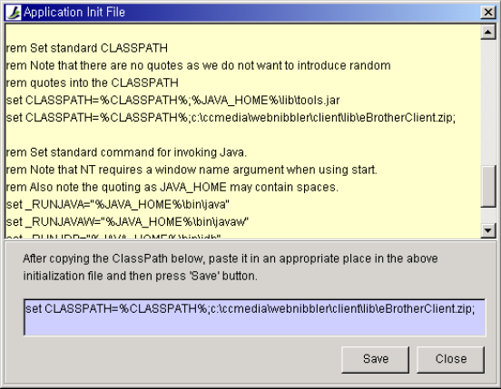
- Paste it in an appropriate spot in the file displayed in the upper box.
- Press Save.
- Press Close.
- Restart the Web Application Server now. Otherwise, WebNibbler LT may not operate properly. You may press the Services button to restart the Web App Server (WAP) from Windows Service Manager, if WAP can be controlled from Web Service Manager. If not, go to WAP directory and restart it.
- Checkmark the “Application server has been restarted” box
- Press the Next button.

6.3.8. Modifying Login Page
This process will insert a script in your login service page in order to communicate with UserMatcher.

- Press Browse to select the file for login service page on your Website.
- Then press Modify.
- The following screen will appear to let you modify the selected file.

① The Selected Login Page
② Scripts to be inserted in the login page

- If you chose to use the UserMatcher-Client module instead of Cookies in the section “6.3.3. UserMatcher-Client Setup”:
- Select whether the type of login page is ASP (Active Server Page) or JSP (Java Server Page). Depending on the selection, the appropriate scripts to be inserted will appear in the box at the bottom of screen as shown in the above picture.
- Copy the content in the box at the bottom, and then insert it into the login page by pasting it in an appropriate place in the login page as explained below. Because every company has different login page formats, you must make your own judgment to determine where you should insert the scripts.
  - If the login page is a Java Server Page (JSP):
    - Copy and paste the following code to call the include file in an appropriate place. This usually is a place where you find other scripts for include files.
<%@ include file="ebrother_usermatcher.jsp" %>
    - Copy and paste the following script in the login page immediately below the script line that successfully finishes the login process. This script calls the UserMatcher-Client function.
setEbAnonUser5(“[user ID]”,“[Gender Code]”,”[Age]”,“”,“”,“”)

  - If the login page is an Active Server Page (ASP).
    - Copy and paste the following code in an appropriate place. This usually is a place where you find other scripts for include files.
<!--#include file="ebrother_usermatcher.asp" -->
    - Copy and paste the following script in the login page immediately below the script line that successfully finishes the login process. This script calls the UserMatcher-Client function.
setEbAnonUser5(“[user ID]”,“[Gender Code]”,”[Age]”,“”,””,””)

Important: you have to replace User ID, Gender Code and Age with the variables you actually use in your login page script. If you don’t have Gender Code and Age data, then you may leave them blank. If you leave them blank, however, you wouldn’t be able to use customer segmentation feature of WebNibbler LT.
What is setEbAnonUser5?
setEbAnonUser5 is a function defined as an Include File. It is an essential function of UserMatcher-Client . It matches anonymous user with corresponding registered member and handles customer segmentation data (i.e. Gender and Age)
The parameters of the function are as follows:
User ID: User ID is a mandatory data and it passes the user’s login ID.
Gender Code: In general, male=1, female=2, others including corporate membership=3. If you don’t handle the gender information in the current login page, modify your login page to fetch the gender information. If it is not possible to fetch the gender information, then leave it as a blank. If you leave the Gender Code as a blank, then you won’t be able to produce analysis reports by gender.
Age: User’s age (up to 3 digits). If you cannot fetch the age data, then leave it as a blank. However, if you leave it a blank, you won’t be able to produce analysis reports by age.
- After modifying the login page, press the [Save Login File] button to apply the changes. The include file (ebrother_usermatcher.asp or ebrother_usermatcher.jsp) will be copied immediately to the directory where the login page exists.
- Checkmark the “Login Page Modification Completed” box
- Press Next.

- If you chose to use Cookies instead of UserMatcher-Client in the section “6.1.6. UserMatcher-Client Setup”:
- Copy and paste the following script line in the login page to issue a Session Cookie. It should be inserted at the line immediately below the script that processes the user login successfully.

  - If the login page is a Java Server Page:
response.setHeader(“Set-Cookie”, “ccmedia=”+”[User_ID]” + ”_/” + ”[Gender_Code]” + "_/" + ”[Age]” );

  - If the login page is an Active Server Page:
Response.Cookies(“ccmedia”)=“[User_ID]”&"_/"&“[Gender_Code]”&"_/" “[Age]”

- Checkmark the “Login Page Modification Completed” box.
- Press Next.

- View Sample File
For more information on the login page modification, please review the sample file that handles UserMatcher-Client by pressing [View Sample File].

6.3.9. Setup Completed
Congratulations! The installation is now completed.

Press the Finish button.

Chapter 2. Setup For Unix or Linux

Installing WebNibbler LT Client
for
Unix or Linux

Summary of Contents
A. Overview
- System Requirements
- Main Modules of WebNibbler LT Client
- Directories of WebNibbler LT Client

B. Installation
- Begin Installation
- License Agreement
- Entering Serial Number
- Entering Destination Directory
- Entering Recovery Receiver Information
- Entering Domain Information
- Confirming Installation Information
- Copying Files and Setting Up Environment
- Configuring Gatherer
- Setting Up UserMatcher

A. Before You Begin

This chapter provides information on how to install WebNibbler LT Client on your Web server and Web Application Server under Unix or Linux environment.

1. System Requirements
Before you install WebNibbler LT Client for Unix/Linux, make sure your computer system meets the following requirements:

- Operating System:
  - Linux RedHat 6.2 or higher; or
  - Sun Solaris 2.6 or higher;
  - IBM AIX 4.3.2 or higher;
  - HP Unix 11.0.1 or higher;
- Web Server:
  - Apache ver. 1.3.xx or higher; or
  - IIS ver. 5.0 or higher;
  - Netscape ver. Server 3.6 or higher;
  - iPlanet Server ver. 4.0 or higher
- Free hard disk space: At least 300MB

2. Main Modules of WebNibbler LT Client
The followings are the main modules of WebNibbler LT Client that will be installed.

Module Name | Installed on: | Function
Gatherer | Web Server System | Generates Web logs
UserMatcher-Client | Web App Server System | -Identifies unique anonymous users and authenticated users;  -Matches anonymous user’s data with corresponding registered user’s data;  -Generates customer segmentation data for registered users
Recovery-Transfer | Web Server  Web App Server System | Sends logs to WebNibbler LT Server

3. Directories of WebNibbler LT Client
After the completion of the installation, you will find the following directories created under the home directory of WebNibbler LT Client.

Directory | Major Files Contained
[HOME]\client\bin | Executable files, cmd files, vbs files
[HOME]\client\etc | An environment file
[HOME]\client\inbound | Log files created by Gatherer and UserMatcher-Client.  * This directory can be changed by modifying the environment file.
[HOME]\client\log | The system log files of WebNibbler LT Client
[HOME]\client\sample | Sample files for modifying a login page to setup UserMatcher-Client
[HOME]\client\lib | Java class files for UserMathcer-Client.  * Used only if JSP or Servlet is used for the Web service.

B. Installation

1. Begin Installation
- Insert the WebNibbler LT for Unix/Linux Installation CD into the CD-ROM.
- Copy the compressed file WebNibblerLTClient.[OS].tar.gz from the CD to any directory (preferably a new directory) on your computer’s hard disk.
- Uncompress the copied file.
$ gunzip WebNibblerLTClient.[OS].tar.gz
$ tar xvf WebNibblerLTClient.[OS].tar
- Run “Install_WebNibbler_LT_Client.sh”. This program will install WebNibbler LT Client on your computer.

2. License Agreement
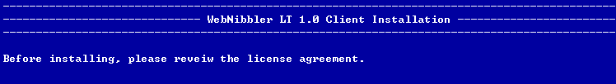
- There is a separate license agreement file, “LICENSE”. Open the file and read it before proceeding to the next step.

3. Entering Serial Number
- Enter your company name and the serial number of WebNibbler LT. If you don’t input the serial number, the program will be installed as a 30 day trial version.
- If you are installing the program as the trial version and purchase the product later, you can register the serial number by running [Home Directory]\bin\RegisterWebNibbler.sh.

4. Entering Destination Directory
- Enter the destination directory where you want to install WebNibbler LT Client files. The default directory is the parent directory of the current working directory. If you want to install to the default directory, press the enter key. The home directory of WebNibbler LT Client will be [Destination Directory]/client.
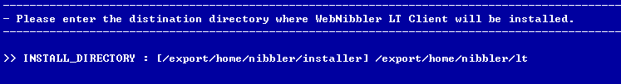
- If the entered directory does not exist, it asks you whether you want to create the directory. Press “y” to create the directory and “n” to terminate the installation process

Caution: The WebNibbler LT Client files will be copied to the directory you enter. Therefore, you must have the “write” privilege for this directory.
Note: The home directory of WebNibbler LT Client will be [Destination Directory]/client.

5. Entering Recovery Receiver Information
1. Enter the IP address of the system on which WebNibbler LT Server is installed.
2. Enter the port number to be used by the Recovery-Receiver module of WebNibbler LT Server. The port number was determined during the installation process of WebNibbler LT Server
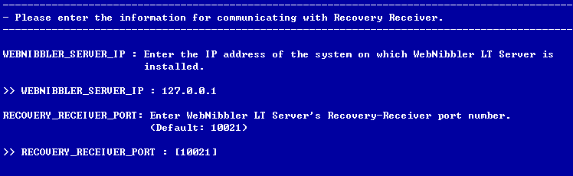
This IP address information is needed for TCP/IP communication between Recovery-Transfer and Recovery-Receiver

6. Entering Domain Information
1. Enter the domain part of URL of the Web site on the Web server on which WebNibbler LT Client is being installed. If the URL is the IP address, enter the IP address. Service Domain is very important information for operation of Gatherer. If your Website is not registered as a Service Domain here, the Web logs won’t be collected even if the Gatherer module is installed on the Website.
Examples:
For http://www.ccmedia.com/index.html, enter www.ccmedia.com.
For http://admin.ccmedia.com/index.html, enter admin.ccmedia.com.
2. Enter the domain of cookie that will be issued from the Web site to Web visitors. In this case, the Web site is the one for which you entered the service domain above. The Cookie Domain is the same as the Domain Host Header. Enter the name of domain from which cookie will be issued to identify the users by WebNibbler LT. If the service domain is an IP address, then enter the IP address as it is.
Examples:
For www.ccmedia.com, .enter ccmedia.com.
For admin.ccmedia.com, enter .ccmedia.com.
For 127.0.0.1, enter 127.0.0.1.
3. Log Domain is a logical/virtual domain name used by WebNibbler LT to group Websites to integrate Web logs from different Websites in analysis. You can assign any name including the name of Service Domain.
Examples:
If you have three Websites, wwww.ccmedia.com, admin.ccmedia.com, and www.ccmedia.net:
- To integrate and analyze the logs from three sites together:
        - For www.ccmedia.com, enter .ccmedia
        - For admin.ccmedia.com, enter .ccmedia
        - For www.ccmedia.net, enter ccmedia.
      - To integrate the logs from www.ccmedia.com and admin.ccmedia.com only and analyze www.ccmedia.net separately, assign any two Log Domain names you like.
        - For www.ccmedia.com, enter .ccmedia
        - For admin.ccmedia.com, enter .ccmedia
        - For www.ccmedia.net, enter www.ccmedia.net
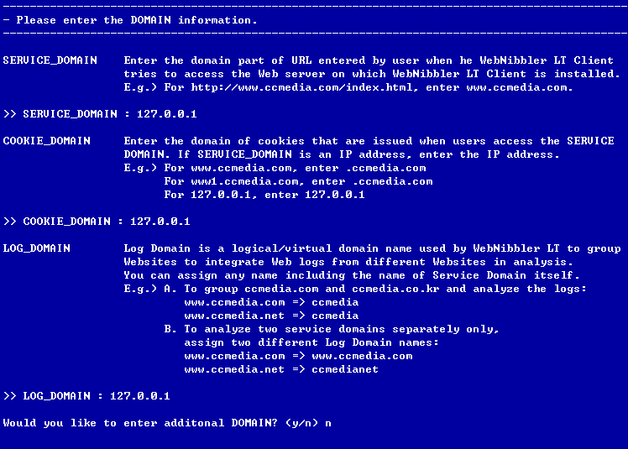
Note: After entering the Log Domain, it will ask you if you want to register additional Log Domains. If you do, enter ‘y’ to repeat the “5. Entering Domain Information” process starting with the Service Domain registration.

7. Confirming Installation Information
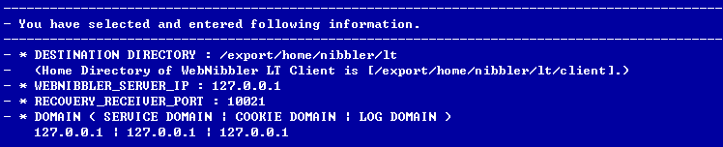
- What you have entered so far is displayed. Read it to confirm that the information is correct.

8. Copying Files and Setting Up Environment
- You are asked to if you want to continue the installation process. Press ‘y’ to proceed, and ‘n’ to quit.
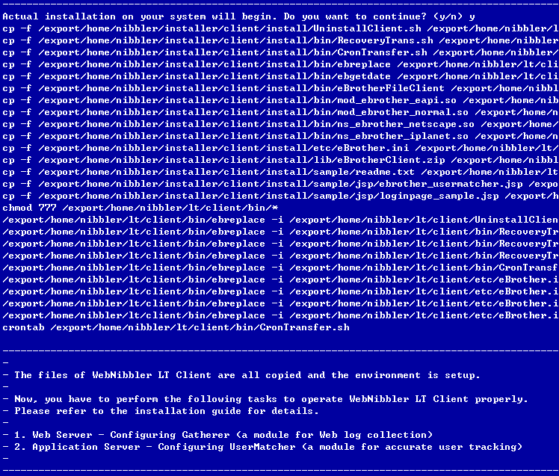
The screen displays the process of copying the files and setting up the environment. When the process is completed, proceed to the step 9 for additional installation processes.

9. Configuring Gatherer
In order to operate Gatherer, the environment configuration of the Web server has to be revised. Depending on your Web server type, go to an appropriate section.
9.1. Configuring on Apache
9.2. Configuring on Netscape
9.3. Configuring on iPlanet

9.1. Configuring on Apache
1. Open the httpd.conf file.
httpd.conf is located in the subdirectory “conf” under the directory where the Apache is installed.

2. Modify the httpd.conf file.
Append the following lines to the httpd.conf file.
LoadModule ebrother_module “<WebNibbler LT Client Home>/bin/mod_ebrother.so” AddModule mod_ebrother.c <IfModule mod_ebrother.c> eBrotherConfig “<WebNibbler LT Client Home>/etc/eBrother.ini” </IfModule>

Exception:
If there is a ClearModuleList section in httpd.conf, then insert the first line “LoadModule ebrother_module “<WebNibbler LT Client Home>/bin/mod_ebrother.so” right above the ClearModuleList section, and insert the rest four lines at the end of the file.

3. Restart the Apache
After modifying httpd.conf, you have to restart the Apache server to run the Gatherer module.

9.2. Configuring on Netscape
1. Open the obj.conf file.
obj.conf is located in the subdirectory “config” under the Netscape’s service directory. If several Web services are provided from the Netscape server, edit obj.conf in each service directory. Gatherer will operate only for the services whereby the obj.conf files are modified.

2. Modify the obj.conf file.
Insert the following lines in obj.conf.
Init fn=”load modules” shlib=”<WebNibbler LT Client Home>/bin/ns_ebrother.so” funcs=”ebrother-init,ebrother-log” Init fn=”ebrother-init” file=”<WebNibbler LT Client Home>/etc/eBrother.ini”
<Object name=default>
AuthTrans fn=”ebrother-log” name=”AuthTrans”

3. Restart the Netscape server.
After modifying obj.conf, you have to restart the Netscape server to run the Gatherer module.

9.3. configuring on iPlanet
1. Open the files, obj.conf and magnus.conf.
The files, obj.conf and magnus.conf are located in the subdirectory “config” under the iPlanet’s service directory. If there are several Web services provided by the iPlanet server, then edit obj.conf and magnus.conf in each service directory. Gatherer will operate only for the services whereby obj.conf and magnus.conf are modified.

2. Modify obj.conf
Insert the following line under the <Object name=default> section in obj.conf.
AuthTrans fn=”ebrother-log” name=”AuthTrans”

- Modify magnus.conf
Append the followings to the magnus.conf file.
Init fn=”load modules” shlib=”<WebNibbler LT Client Home>/bin/ns_ebrother.so” funcs=”ebrother-init,ebrother-log” Init fn=”ebrother-init” file=”<WebNibbler LT Client Home>/etc/eBrother.ini”

- Restart the iPlanet server.
After modifying obj.conf and magnus.conf, you have to restart the iPlanet server to run the Gatherer module.

10. Setting UP UserMatcher
Now, you are ready to install a UserMatcher feature. The UserMatcher feature performs a function of mapping an anonymous user’s records to corresponding registered member’s records when the user logs in.
There are two ways of using UserMatcher feature: using the UserMatcher-Client module and using cookies.

- Use Cookies
This method utilizes a session cookie named “ccmedia” which contains the member’s login ID, gender and age. In order to use this method, it must be possible to issue the cookie from the login page. If, for security reasons or any other reason, the cookie cannot be issued, then please use User Matcher module instead.

- Use UserMatcher-Client Module (Recommended)
The UserMatcher-Client module is used to obtain an authenticated user’s mapping data and customer segmentation data. The obtained data is stored in a file under WebNibbler LT’s subdirectory “inbound”.

If you are unsure which one to use, choose the “Use UserMatcher-Client Module” option.
If your Website does not have the user login processes, you don’t need to setup the UserMatcher function. Go directly to “8. Adding Domains”.

Depending on your selection go to an appropriate section:

10.1. Using Cookies
10.2. Using UserMatcher-Client Module

10.1. Using Cookies
The value of cookie key to be issued is set up at the MEMBERID line user the [USERMATCHER] section in the eBrother.ini file. The default cookie key name is “ccmedia”. If you change the cookie key name to something else, you have to restart the Web server.
- Setup the cookie issuing method. The cookie is issued from your login page using one of these two methods. Choose a method and change your login page accordingly.

Method 1. Insert the following lines in the login page:
Cookie cookie = new Cookie(“ccmedia”,”cookie value”);
response.addCookie(cookie);

Method 2. Insert the following line in the login page:
response.setHeader(“Set-Cookie”,”cookie value”);

Here, the value of cookie consists of the logged-in user’s data separated by “_/” as shown below.
loginID_/gender_/age_/UserSegment1_/UserSegment 2_/UseSegment3
Explanation:
[1] : login ID (mandatory) [2] : gender (optional): “1”-male, “2”-female, “3”-other [3] : age (optional) [4] : a user segment data 1 (optional): values from 1 to 9 [5] : a user segment data 2 (optional): values from 1 to 9 [6] : a user segment data 3 (optional): values from 1 to 9
A user segment data is determined by the user segment method used by your site, and its values are integers from 1 through 9. For instance, you can have a user segment based on nationalities: 1 for Citizen, 2 for Permanent Resident, 3 for Alien; or you based on the customer value: 1 for Premium Customer, 2 for Regular Customer, etc. To implement these optional segment items, your Website and login page must be able to fetch the corresponding data. As defaults, we recommend you to handle the gender and age data and pass them on to the UserMatcher function.
For an optional variable (String[x]) that is not used, enter the empty string (“”) in its place.

10.2. Using UserMatcher-Client Module

10.2.1. Setting up App Server Environment
- Open the file where can add CLASSPATH.
- Insert the following line in the file to add the path of eBrotherClient.zip in the CLASSPATH. This will enable the App Server use UserMatcher-Client Java Class.
CLASSPATH=$CLASSPATH:<WebNibbler LT Client Home>/lib/eBrotherClient.zip
- After modifying the CLASSPATH, restart the App Server.

10.2.2. Modifying Login Page
- Copy the following file into the directory where the login page is located.
<WebNibbler LT Client Home>/sample/jsp/ebrother_usermatcher.jsp

- Insert the following line in the include file section of the login page.
<%@ include file=”ebrother_usermatcher.jsp”%>

- Insert the following script immediately below the script line that successfully finishes the login process in the login page. This script calls the UserMatcher-Client function.
setEbAnonUser5(HttpServerRequest [1], HttpServletResponse [2], String [3], String [4], String [5], String [6], String [7], String [8] );
Explanation:
[1] : request object (mandatory) [2] : response object (mandatory) [3] : login ID (mandatory) [4] : gender (optional): “1”-male, “2”-female, “3”-other [5] : age (optional) [6] : a user segment data (optional): values from 1 to 9 [7] : a user segment data (optional): values from 1 to 9 [8] : a user segment data (optional): values from 1 to 9
A user segment data is determined by the user segment method used by your site, and its values are integers from 1 through 9. For instance, you can have a user segment based on nationalities: 1 for Citizen, 2 for Permanent Resident, 3 for Allien; or you based on the customer value: 1 for Premium Customer, 2 for Regular Customer, etc. To implement these optional segment items, your Website and login page must be able to fetch the corresponding data. As defaults, we recommend you to handle the gender and age data and pass them on to the UserMatcher function.
For an optional variable (String[x]) that is not used, enter the empty string (“”) in its place.

PART IV. USING WEBNIBBLER LT

In Part IV, the system manual for WebNibbler LT Server is provided.

Summary of Contents
Part IV is organized into the following chapters:

- Chapter 1, “System Overview,” describes the overview of WebNibbler LT system including the directory and file structures and log files.
- Chapter 2, “System Configuration & Operation,” describes how to change the configuration of the WebNibbler LT modules.

Chapter 1. System Overview

WebNibbler LT
System Overview

Summary of Contents
- Modules of WebNibbler LT
- Overall System Diagram
- Directories and Files of WebNibbler LT
- Log Files

Main Modules of WebNibbler LT
WebNibbler LT generates, stores and processes Web logs to create summary data for various analysis and reports.
There are five modules in WebNibbler LT: three in WebNibbler LT Client and two in WebNibbler LT Server.

1. WebNibbler LT Client:
- WebNibbler LT Client is installed on the Web server and Web Application Server
- WebNibbler LT Client consists of the following three modules:
1. Gatherer: is plugged in the Web server and generates Web logs in text files. The Web logs are not created in the traditional log format but in WebNibbler LT’s own format optimized for effective Web analytics. generates Web logs
2. UserMatcher-ClientClient: is an optional module that is installed on your Web Application Server. It performs a function of capturing user login information and generating the log files. If your site is able to leave the login data as a cookie, then it is possible to use Gatherer to perform the same function without UserMatcher-ClientClient. You can select either UserMatcher-ClientClient mode or Cookie mode at the time of installation. If your site does not handle the user login process, then you don’t need this module.
3. Recovery-Transfer: is a module installed on the Web server that transmits the Web logs generated by Gatherer and UserMatcher-Client to the Recovery-Transfer module of WebNibbler LT Server.

2. WebNibbler LT Server:
- WebNibbler LT Server installed on the administrator’s computer to store and process the Web logs.
- WebNibbler LT Server consists of the following two modules:
1. Recovery-Receiver: receives and stores the Web logs sent by Recovery-Transfer module of WebNibbler LT Client
2. RPTPre: processes the Web logs to create the summary data used for analysis and reports.

Overall System Diagram

Example: the following illustrates how WebNibbler LT works.
- Gatherer:
- A user accesses the Website via Web browser, such as Internet Explorer.
- Gatherer collects the user activity information on the Website and generates a Web log.
- The Web log is saved in a Web log file.

- UserMatcher-Client
- The user logs in.
- The login information is sent to the Web Application Server for processing.
- If the log-in is successful, the login data is sent to UserMatcher-Client.
- UserMatcher-Client generates a log containing the login information
- The log is saved in a Web log file on the Web server.

- Recovery-Transfer
- At a specified time (set in the Scheduled Tasks), the log files are sent to Recovery-Receiver. By default, the log files are sent once every hour.

- Recovery-Receiver
- Recovery-Receiver receives and saves the log files sent by Recovery-Transfer.

- RPTPre
  - RPTPre runs at a specified time (set in the Scheduled Tasks) to process the accumulated log files to generate the summary data text files in RDBMS raw data format. By default, RPTPre runs once every day at 2:00 a.m..

3. Directories and Files of WebNibbler LT

3.1. Directories and Files of WebNibbler LT Client
The following is the directory structure for WebNibbler LT Client.
Directory | Files Contained
[HOME]\client\bin | Executable files, cmd files, vbs files
[HOME]\client\etc | An environment file
[HOME]\client\inbound | Log files created by Gatherer and UserMatcher-Client.  * This directory can be changed by modifying the environment file.
[HOME]\client\doc | Document files
[HOME]\client\sample | Sample files for modifying a login page to setup UserMatcher-Client
[HOME]\client\lib | Java class files for UserMathcer-Client.  * Used only if JSP or Servlet is used for the Web service.

For Gatherer, the following files are used.
Web Server Type | Directory & File | Description
IIS | [HOME]\bin\ms_ebrother.dll | C program file plugged in the Web server.
Apache | [HOME]\bin\mod_ebrother.dll | C program file plugged in the Web server.
Netscape/iPlanet | [HOME]\bin\ns_ebrother.dll | C program file plugged in the Web server.
All | [HOME]\bin\eBrother.ini | Environment file

For Recovery-Transfer, the followings files are used.
Directory & File | Description
[HOME]\bin\eBrotherFileClient.exe | An executable program that transmits log files to Recovery-Receiver.
[HOME]\bin\RecoveryTrans.cmd | A command program that executes eBrotherFileClient.exe. (This file is executed by the Work Schedule.)

3.2. Directories and Files of WebNibbler LT Server

- The following is the directory structure for WebNibbler LT Server.
Directory | Files Contained
[HOME]\server\bin | Executable files, cmd files, vbs files
[HOME]\server\etc | Environment file
[HOME]\server\inbound | Web log files received by Recovery Receiver
[HOME]\server\lib | Library files
[HOME]\server\jre | WebNibbler LT Server Java Home
[HOME]\server\log | System log files generated when WebNibbler LT modules are executed..
[HOME]\server\report | Summary files and temporary files created by RPTPre
[HOME]\server\doc | Document files

- For Recovery-Receiver, the followings files are used.
Path & File | Description
[HOME]\bin\startfileserver.cmd | A command program that starts Recovery-Receiver
[HOME]\bin\stopfileserver.cmd | A command program that stops Recovery-Receiver
[HOME]\bin\restartfileserver.cmd | A command program that restarts Recovery-Receiver  (executed by Scheduled Tasks)
[HOME]\lib\eBrotherServer.zip | Recovery Receiver Java Class
[HOME]\lib\eBrotherInstall.jar | A java class that is used to stop Recovery-Receiver
[HOME]\etc\eBrotherServer.ini | An environment file
[HOME]\bin\Fport.exe | A program that lists the execution process IDs. It is used to find the process ID of Recovery-Receiver.
[HOME]\bin\pskill.exe | An executable program that is used to kill a process. It can be used to kill the Recovery-Receiver process.
[HOME]\bin\ebgetdate.exe | An executable program that acquires the date
[HOME]\bin\ebrotherenv.cmd | A command program for setting up environment variables used in executing the command programs.

- For the RPTPre module, the followings files are used.
Path & File | Description
[HOME]\bin\RPTPreext.exe | RPTPre program
[HOME]\bin\wbreport_pre.cmd | A command program that executes rptpreext.exe  (Executed by Scheduled Tasks.)
[HOME]\etc\eBrotherRpt.ini | An environment file
[HOME]\bin\ebgetdate.exe | An executable program that acquires the date.
[HOME]\bin\ebrotherenv.cmd | A command program for setting up environment variables used in executing the command programs.

- To delete the old log files, the followings files are used.
Path & File | Description
[HOME]\bin\wb_del_file_RPTPre.cmd | A command program that deletes old log files. (Executed by Scheduled Tasks)
[HOME]\bin\ebrotherenv.cmd | A command program for setting up environment variables used in executing the command programs.

4. Log Files
- Basically there are two types of log files generated by WebNibbler LT Client: Gatherer log files and UserMatcher-Client log files.

- Periodically, Recovery-Transfer sends the log files to the Recovery-Receiver module of WebNibbler LT Server. When the log files are transferred successfully, they are automatically deleted from the WebNibbler LT Client system.
- The copies of the log files are saved by Recovery-Receiver on the WebNibbler LT Server system.

- Once a day, RPTPre processes the log files saved by Recovery-Receiver to extract the summary log data.

- The Summary log data is readily usable for reports or analysis.

.

4.1. Log Files of Gatherer
The Gatherer logs are generated in real-time and a new log file is created once every hour.

- File Name Format: yyyymmddhh.log, whereby “yyyymmddhh” denotes the date and time of the log file creation.
- Default File Location: [HOME]\client\inbound
- File Content: The following record is generated by Gatherer for each valid Web user activity.

Field | Description
HTTP_CC_GUID | A cookie value for identifying an anonymous user
HTTP_CC_SESSION | A session value for identifying a session (visit)
SERVER_HOST | A value of Log Domain. The Log Domain is setup in [COOKIE] section of the environment file.
SERVER_URL | Requested URL
REMOTE_ADDR | An IP address of the Web user’s system
REMOTE_USER | An authenticated user’s data. It is the same as the cookie value setup in [USERMATCHER] MEMBERID section of the environment file.
USER_AGENT | The Web user’s browser type
HTTP_URI | The value is 1 if it is the first pageview (i.e. entry page) for the current visit; otherwise, the value is 0.
HTTP_REFERER | A referral URL (i.e. the URL of a previous Web page)
HTTP_COOKIE | Not used
HTTP_METHOD | POST/GET
HTTP_TIME | The time of request in yyyymmddhhmmss format
HTTP_QUERY | A request query string

- Example of a Gatherer log record:

HTTP_CC_GUID="200312161529267301a8c005b00000" HTTP_CC_SESSION="200312161529267301a8c005b00000" SERVER_HOST="127.0.0.1" SERVER_URL="/" REMOTE_ADDR="127.0.0.1" REMOTE_USER="" USER_AGENT="Mozilla/4.0 (compatible; MSIE 6.0; Windows NT 5.0)" HTTP_URI="1" HTTP_REFERER="" HTTP_COOKIE="" HTTP_METHOD="GET" HTTP_TIME="20031216152926" HTTP_QUERY=""

For easier view, the followings show the content of the above log record:
HTTP_CC_GUID="200312161529267301a8c005b00000"
HTTP_CC_SESSION="200312161529267301a8c005b00000"
SERVER_HOST="127.0.0.1"
SERVER_URL="/"
REMOTE_ADDR="127.0.0.1"
REMOTE_USER=""
USER_AGENT="Mozilla/4.0 (compatible; MSIE 6.0; Windows NT 5.0)"
HTTP_URI="1"
HTTP_REFERER=""
HTTP_COOKIE=""
HTTP_METHOD="GET"
HTTP_TIME="20031216152926"
HTTP_QUERY=""

4.2. Log Files of UserMatcher-Client
The UserMatcher-Client logs are generated in real-time and a new log file is created once every hour.

- File Name Format: yyyymmddhh.login.log, whereby “yyyymmddhh” denotes the date and time of the log file creation.
- Default File Location: [HOME]\client\inbound
- File Content: The following record is generated by UserMatcher-Client for each valid Web user log-in. The record format is the same as that of Gatherer except that only four fields are used:

Field | Description
HTTP_CC_GUID | A cookie value for identifying an anonymous user
HTTP_CC_SESSION | A session value for identifying a session (visit)
SERVER_HOST | Not used
SERVER_URL | Not used
REMOTE_ADDR | Not used
REMOTE_USER | An authenticated user’s data. It is the same as the cookie value setup in [USERMATCHER] MEMBERID section of the environment file.
USER_AGENT | Not used
HTTP_URI | Not used
HTTP_REFERER | Not used
HTTP_COOKIE | Not used
HTTP_METHOD | Not used
HTTP_TIME | The log-in time in yyyymmddhhmmss format
HTTP_QUERY | Not used

- Example of a UserMatcher-Client log record:

HTTP_CC_GUID="200312161529267301a8c005b00000" HTTP_CC_SESSION="200312161529267301a8c005b00000" SERVER_HOST="" SERVER_URL="" REMOTE_ADDR="" REMOTE_USER="TEST_/1_/30_/_/_/" USER_AGENT="" HTTP_URI="" HTTP_REFERER="" HTTP_COOKIE="" HTTP_METHOD="" HTTP_TIME="20031216174550" HTTP_QUERY=""

For easier view, the followings show the content of the above log record:
HTTP_CC_GUID="200312161529267301a8c005b00000"
HTTP_CC_SESSION="200312161529267301a8c005b00000"
SERVER_HOST=""
SERVER_URL=""
REMOTE_ADDR=""
REMOTE_USER="TEST_/1_/30_/_/_/"
USER_AGENT=""
HTTP_URI=""
HTTP_REFERER=""
HTTP_COOKIE=""
HTTP_METHOD=""
HTTP_TIME="20031216174550"
HTTP_QUERY=""

4.3. The Log Files Stored by Recovery-Receiver
When Recovery-Receiver receives the log files generated by Gatherer and UserMatcher-Client, it stores the files by adding the IP address of the system on which WebNibbler LT Client is installed to the file name.

- File Name Formats:
yyyymmhhdd_[WebNibbler LT Client IP].log; or
yyyymmhhdd.login_[WebNibbler LT Client IP].log
where
yyyymmhhdd is from the original file names of the Gatherer logs;
yyyymmhhdd.login is from the original file names of the UserMatcher-Client logs;
[WebNibbler LT Client IP] is the IP address of the system on which WebNibbler LT Client exists.

- Default File Location: [Home Directory of WebNibbler LT Server]\server\inbound

- File Content: the same as that of the original Gatherer and UserMatcher-Client log files.

4.4. Summary Log Files Generated by RPTPre
By processing the log files saved by Recovery-Receiver, the RPTPre module generates summary files which can be readily used in the reports or analysis.

- File Name Formats: There are eight different files.
File Name | Description
Nblog_dbm.dat | A file of pageview data
nbvisit_dbm.dat | A file of visit data
Nbsite_dbm.dat | A file of site data
nbpath_dbm.dat | A file of path data
Nbfile_dbm.dat | A file of file data
nbquery_dbm.dat | A file of query string data
nbrefsite_dbm.dat | A file of referral site data
nbrefurl_dbm.dat | A file of referral URL (previous page) data
nbrefquery_dbm.dat | A file of referral query string data
nbagent_dbm.dat | A file of agent data(browser type)

- Default File Location: [Home Directory of WebNibbler LT Server]\server\report

- File Content: The .following sections present the tables of file contents.

4.4.1. File Content (Fields of Log Records)
The followings are the data descriptions of the summary log files.

- File Name: nblog_dbm.dat

Column Name | Fixed Length | Description
Idlog | 10 | A serial number of log
Idvisit | 32 | A session value issued by Gatherer
Idsite | 10 | An index value of site
Idpath | 10 | An index value of path
Idfile | 10 | An index value of file
Idquery | 10 | An index value of query string
Idrefsite | 10 | An index value of referral site
Idrefurl | 10 | An index value of referral URL (previous page)
Idip | 15 | An IP address of user’s browser
Idrefquery | 10 | An index value of referral query string
Idymd | 8 | Access date (yyyymmdd)
Idhms | 6 | Access time (hhmiss)
Idagent | 10 | An index value of Agent (browser type)
Valduration | 10 | A page visit length (time duration)
Idfileexact | 10 | Not used

- File Name: nbvisit_dbm.dat
The columns are separated by a comma (“,”) in the record.
Column Name | Description
Idvisit | A value of session issued by Gatherer to identify the visit. It is a unique key value of this record.
Idcookie | A value of cookie issued by Gatherer to identify the user.
Userid | An authenticated user’s data. It is input when the user logs in while visiting the Website. (Format: UserID_/Gender_/Age_Other1_Other2_/Other_3)
Idsite | An index value of site
Islogin | A value indicating whether the user logged in during the visit (0: Not logged in, 1: Logged in)
Cntview | Number of pageviews during the visit
Cntdurate | Duration of visit (unit: millisecond)
Isemail | A value indicating whether the user visited via e-mail message. (Not supported by WebNibbler LT)
Idsymdhms | Starting date and time of the visit ( yyyymmddhhmmss )
Idfile | An index value of file used when the visit started (i.e. entry page)
Idrefsite | An index value of referral site
Idrefurl | An index value of referral URL (i.e. previous page)
Ideymdhms | Ending date and time of the visit ( yyyymmddhhmmss )
Idefile | An index value of the file used for ending the visit.
Iderefurl | An index value of referral URL at the time of ending the visit (i.e. the second last page.)
Idloginymdhms | A value of date and time the user logged in (yyyymmddhhmmss)
Isfirst | A value indicating if this was the first visit by the user  (0: returning visit, 1: first time visit)

- File Name: nbsite_dbm.dat
Column Name | Fixed Length | Description
Idsite | 10 | An index value of site
Data | 255 | Log Domain
Admindate | 14 | A value of data creation date

- File ame: nbpath_dbm.dat
Column Name | Fixed Length | Description
Idpath | 10 | An index value of path
Idsite | 10 | An index value of site
Pathall | 255 | Path
Cntread | 10 | Number of times queried (optional)
Admindate | 14 | A value of data creation date

- File Name: nbfile_dbm.dat
Column Name | Fixed Length | Description
Idfile | 10 | An index value of file
Idpath | 10 | An index value of path
Idsite | 10 | An index value of site
Filename | 255 | A name of file
Cntread | 15 | Number of times queried (optional)
Admindate | 14 | A value of data creation date

- File Name: nbquery_dbm.dat
Column Name | Fixed Length | Description
Idquery | 10 | An index value of query string
Idfile | 10 | An index value of file
Data | 255 | A query string
Admindate | 14 | A value of data creation date

- File Name: nbrefsite_dbm.dat
Column Name | Fixed Length | Description
Idrefsite | 10 | An index value of referral site
Data | 255 | Referral site
admindate | 10 | A value of data creation date

- File Name: nbrefurl_dbm.dat
Column Name | Fixed Length | Description
idrefurl | 10 | An index value of referral URL (previous page)
idrefsite | 10 | An index value of referral site
Data | 255 | A referral URL (URL of previous page)
anchor | 10 | Not used
admindate | 14 | A value of data creation date

- File Name: nbrefquery_dbm.dat
Column Name | Fixed Length | Description
idrefquery | 10 | An index value of referral query string
idrefurl | 10 | An index value of referral URL (previous page)
Data | 255 | A referral query string
anchor | 10 | Not used
admindate | 14 | A value of data creation date

- File Name: nbagent_dbm.dat
Column Name | Fixed Length | Description
idagent | 10 | An index value of agent (Browser Type)
Data | 255 | An agent (Browser Type)
admindate | 14 | A value of data creation date

4.4.2. Entity Relation Diagram of RPTPre Log Files

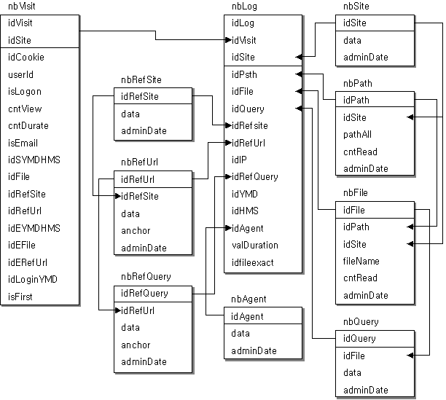

Chapter 2. System Configuration & Operation
WebNibbler LT
System Configuration & Operation

Summary of Contents
- Overview
- Adding a new Service Domain
- Removing a Service Domain
- Adding a new Web server
- Removing a Website/Web server
- Stopping Gatherer
- Changing Cookie Information
- Stopping UserMatcher-Client
- Stopping Recovery-Transfer
- Restarting Recovery-Transfer
- Changing Execution Schedule for Recovery-Transfer
- Stopping Recovery-Receiver
- Restarting Recovery-Receiver
- Stopping RPTPre
- Restarting RPTPre or Changing Execution Schedule for RPTPre
- Deleting Old Log Files

1. Overview
This chapter provides information on how to configure or operate WebNibbler LT Server under Microsoft Windows 2000/2003 environment.

The following table shows when each module of WebNibbler LT runs:
System | Module | Default Execution Schedule
WebNibbler LT Client | Gatherer | Runs all the time
WebNibbler LT Client | UserMatcher-Client | Runs every hour
WebNibbler LT Client | Recovery-Transfer | Runs every hour
WebNibbler LT Server | Recovery-Receiver | Runs all the time
WebNibbler LT Server | RPTPre | Runs at 2:00 a.m. every day

In the following sections, you will learn how to stop or restart each module, change the configuration, and change the time of executing each module in the Scheduled Tasks.

2. Adding a New Service domain
- Open [Home Directory of WebNibbler LT Client]\etc\eBrother.ini using a text editor. (e.g. notepad)
- Under the [COOKIE] section, add the following line:
[Service Domain]=ccguid|ccsession|[Cookie Domain]]|20101231235959|/|[Log Domain]
For information on Service Domain, Cookie Domain, Log Domain, refer to the Cookie Information Setup section in the Installation Guide.
- Restart the Web server on which Web Nibbler LT Client is installed.

3. Removing a Service Domain
- Open [Home Directory of WebNibbler LT Client]\etc\eBrother.ini using a text editor. (e.g. notepad)
- Under the [COOKIE] section, delete the line that contains the corresponding Service Domain information.
- Restart the Web server on which Web Nibbler LT Client is installed.

4. Adding a New Web Server
- Install Gatherer on the Web server using the installation program or follow the installation guide.

5. Removing a Website/Web server
- For Apache:
- Open the file [Apache Directory]\conf\httpd.conf using a text editor.
- Delete the following lines:
LoadModule ebrother_module "[HOME]/bin/mod_ebrother.dll"
AddModule mod_ebrother.c
<IfModule mod_ebrother.c>
eBrotherConfig "[HOME]/etc/eBrother.ini"
</IfModule>
- Restart the Apache server

- For Netscape/iPlanet
- Open the file [Netscape or iPlanet Home Directory]\config\obj.conf using a text editor.
- Delete the following lines. (For iPlanet, delete the same in magnus.conf as well.)
Init fn="load-modules" shlib=" [HOME]/bin/ns_ebrother.dll"
funcs="ebrother-init,ebrother-log"
init fn="ebrother-init" file=" [HOME]/etc/eBrother.ini"
AuthTrans fn="ebrother-log" name="AuthTrans"
- Restart the Netscape/iPlanet server.

6. Stopping Gatherer
The operation of Gatherer cannot be stopped. If you do not wish to generate the logs any more, remove the Gatherer module from the Web server. (See “5. Removing a Website/Web server)

7. Changing Cookie Information manually
      - Open the file [Home]\etc\eBrother.ini using a text editor.
      - Change the [USERMATCHER]MEMBERID section.
      - Modify the cookie key in the section where cookie is issued in the login page.
      - If the Web server is an IIS, restart it. If you are using a separate Web Application Server, you must restart the Web Application Server.

8. Stopping UserMatcher-Client
The operation of UserMatcher-Client cannot be stopped. If you wish to remove the UserMatcher function, then delete the relevant codes in the login page.

9. Stopping Recovery-Transfer
- On the system where WebNibbler LT Client is operating, open Start→Programs→WebNibbler LT→Scheduled Tasks.
- Click the right mouse button on “RecoveryTrans_00_23” and open the registration information. (R)
- Under the Task tab, uncheck “Use” item.

10. Restarting Recovery-Transfer
- On the system where WebNibbler LT Client is operating, open Start→Programs→WebNibbler LT→Scheduled Tasks.
- Click the right mouse button on “RecoveryTrans_00_23” and open the registration information. (R)
- Under the Task tab, checkmark the “Use” item.

11. Changing the schedule for execution of Recovery-Transfer
- On the system where WebNibbler LT Client is operating, open Start→Programs→WebNibbler LT→Scheduled Tasks.
- Click the right mouse button on “RecoveryTrans_00_23” and open the registration information. (R)
- Select the Schedule tab.
- Change the desired time for execution of Recovery-Transfer.

12. Stopping Recovery-Receiver
- On the system where WebNibbler LT Server is operating, open Start→Programs→WebNibbler LT→Recovery-Receiver→Stop.

13. Restarting Recovery-Receiver
- On the system where WebNibbler LT Server is operating, open Start→Programs→WebNibbler LT→Recovery-Receiver→Stop.
- Open Start→Programs→WebNibbler LT→Recovery-Receiver→Start.

14. Stopping RPTPre
- On the system where WebNibbler LT Server is operating, open Start→Programs→WebNibbler LT→Scheduled Tasks.
- Right click on NB_ExecRPTPRE and open the Registration Information (R).
- Under the Task tab, uncheck “Use” item.

15. Restarting RPTPre or Changing the Schedule for execution of RPTPre
- On the system where WebNibbler LT Server is operating, open Start→Programs→WebNibbler LT→Scheduled Tasks.
- Right click on NB_ExecRPTPRE and open the Registration Information (R).
- Set the desired time for execution of RPTPre.

16. Deleting Old Log Files
When the log files are sent from Recovery-Transfer to Recovery-Transfer, they are deleted from the WebNibbler LT Client system immediately.
Recovery-Receiver keeps copies of the log files on the WebNibbler LT Server system. When these files are kept for a sufficiently long time, they are deleted. By default, the log files older than two weeks are deleted automatically. If you want to change the age requirement for the deletion of log files:
- Open [Home Directory of WebNibbler LT Server]\bin\ebrotherenv.cmd using a text editor.
- Change the value of WEBDEL_VISIT.

17. Executing and Configuring Rptpre Manually
In order to execute RPTPre manually, run the rptpreext.exe program from the command prompt. When you run specify the log date, initialization file and working directory as parameters.
For example, when you want to manually process the logs of March 12, 2004 under an MS Windows environment, execute the following command:
> rptpreext.exe 20040312 ..\etc\eBrotherRpt.ini ..\inbound ..\report\pre\result

To change the configuration related to RPTPre, modify the [PRERPT] section in the eBrotherRpt.ini file.

Key | Description | Default
DATAPATH | A directory path where the log data exists. | .
PREPATH | A directory path where the processed summary data will be stored. | .
TEMPPATH | A directory path where temporary data will be created. | .
CASE_SENSITIVE | A value that determines if data is case sensitive or not.  (0:Not case sensitive, 1:Case sensitive) | 1
SORT | A value that determines if data is to be sorted within RPTPre  (0: Not sorted, 1:Sorted) | 1

Port number for Recovery-Receiver module. You can choose any port as long as it is not being used by another application. The default and recommended port number is 10021.
If you don’t have the user login process on your Website, you don’t need to install the UserMatcher-Client module of WebNibbler LT Client. In this case, however, it is highly recommended to implement user registration and login system on your Website to collect better information on your customers and to have more thorough analysis.

